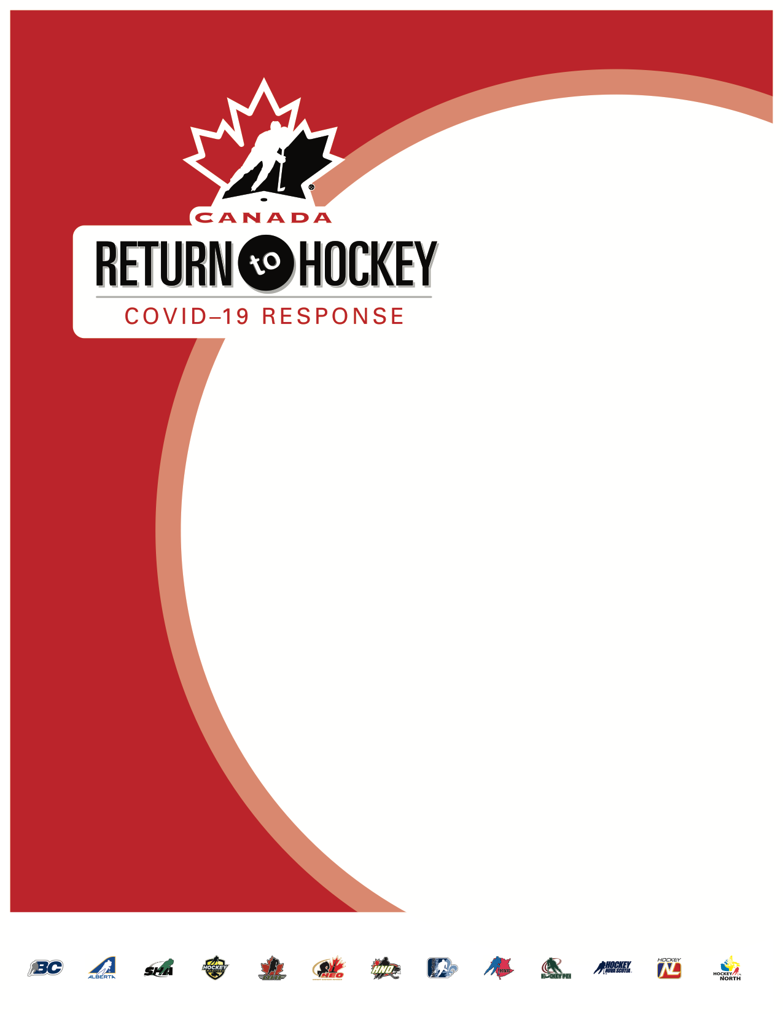

Return to Hockey
ASSOCIATION PLAN

Click here to enter text.
Minor Hockey Association

Instructions
- Download the template from the Hockey NL website and save a copy on your local computer.
- Title the saved document as RTH Plan [your Association].docx, for example RTH Plan Bonavista.docx
- Complete each section, checking the boxes, selecting dates and inserting text as required.
- If there is insufficient space for entering text, you can provide the information in another document included with the plan.
- An alternative to proving descriptions or answering the question in this template document is to create a separate document that provides all of the information requested.
- When completed, send the RTH plan, and all additional information requested, to the Hockey NL Office by email.

Each association and league’s own individual plan for its Return to Hockey must follow the Hockey NL Return to Hockey plan. In places where the association’s plan has to deviate from the Hockey NL Return to Hockey plan, please ensure these differences are highlighted for consideration. Hockey NL will work with individual associations to address these differences to ensure everyone can return to hockey safely.

Resources
In the preparation of their Association specific Return to Hockey plans, Associations should review and follow the following guidelines:

Hockey Canada Return to Hockey guidance
https://www.hockeycanada.ca/en-ca/exclusive/return-to-hockey/plans

Hockey NL Return to Hockey guidance
https://www.hockeycanada.ca/en-ca/exclusive/return-to-hockey/province-updates/nl

Government of Newfoundland & Labrador Sport Guidance
https://www.gov.nl.ca/covid-19/information-sheets-for-businesses-and-workplaces/sport-guidance/

Government of Newfoundland & Labrador Special Measures Order (Masks)
https://www.gov.nl.ca/covid-19/files/Special-Measures-Order-Masks-August-24-2020.pdf

General Information
Name of Association: | Click here to enter text.

Rink(s) used by the association: |  | Click here to enter text.
 |  | Click here to enter text.

Please provide the contact information for the person completing this form:
Name: | Click here to enter text. |  | Position: | Click here to enter text.
Phone No.: | Click here to enter text. |  | E-Mail address: | Click here to enter text.

Please provide the number of Players, Coaches and Group Size anticipated in each Minor division:
Div |  | Players |  | Coaches |  | Group Size
U7 |  | Click here to enter text. |  | Click here to enter text. |  | Click here to enter text.
U9 |  | Click here to enter text. |  | Click here to enter text. |  | Click here to enter text.
U11 |  | Click here to enter text. |  | Click here to enter text. |  | Click here to enter text.
U13 |  | Click here to enter text. |  | Click here to enter text. |  | Click here to enter text.
U15 |  | Click here to enter text. |  | Click here to enter text. |  | Click here to enter text.
U18 |  | Click here to enter text. |  | Click here to enter text. |  | Click here to enter text.

Please provide the number of Players, Coaches and Group Size anticipated in each Female division:
Div |  | Players |  | Coaches |  | Group Size
U9 |  | Click here to enter text. |  | Click here to enter text. |  | Click here to enter text.
U12 |  | Click here to enter text. |  | Click here to enter text. |  | Click here to enter text.
U15 |  | Click here to enter text. |  | Click here to enter text. |  | Click here to enter text.
U18 |  | Click here to enter text. |  | Click here to enter text. |  | Click here to enter text.

Has your association met with your facility management to discuss Return to Hockey protocols?
☐ Yes ☐ No If No please provide details below or attach as a separate document

Click here to enter text.

Does your facility have a COVID-19 protocol your association must follow? ☐ Yes ☐ No
Please provide details below or attach as a separate document.
Click here to enter text.

Will parents be allowed to accompany players into the facility? ☐ Yes ☐ No
Please provide details below or attach as a separate document.
Click here to enter text.

Will there be access to dressing rooms during on-ice sessions? ☐ Yes ☐ No
Please provide details including how physical distancing will be accomplished or attach as a separate document.
Click here to enter text.

Have you met with your Referee in Chief to discuss your plan? ☐ Yes ☐ No
Please provide details on any specific measures needed by your officials or attach as a separate document.
Click here to enter text.

Endorsement of the facility manager:
☐ I have met with the Association, have reviewed their plan, and endorse it.

Name: | Click here to enter text. |  | Email: | Click here to enter text.

Communications Officer
Responsibilities can include:
- Monitoring all updates from the CMO, Hockey NL & Hockey Canada
- Communication with parents on all COVID and Return to Play matters
- Communication with Hockey NL on all COVID and Return to Play matters
- Communication with the local facility on guidelines and updates
- Ensuring teams are following the prevention guidelines set by Hockey NL
- Ensuring COVID-19 cases are reported: Health authority, BC Hockey, MHA, league & facility

☐ Yes, we have appointed our Communications Officer:
Please provide the contact information for the Communications Officer:

Name: | Click here to enter text. |  | Position: | Click here to enter text.
Phone No.: | Click here to enter text. |  | E-Mail address: | Click here to enter text.

Facilities
A ‘Return to Hockey’ plan should include details for all facilities that your Associations plans to use. Therefore, the following section may need to be completed for each individual facility. Also, facility guidelines may need to be evaluated during each phase and updated:

Facility Name: ______________________________________________________________

Do you use more than one facility? ☐ Yes ☐ No
Please answer the remaining questions for your primary facility, or attach as a separate document. If you use more than one facility include information unique to those facilities in a separate document.

What facility guidelines and requirements are in place specific to physical distancing?
Click here to enter text.

Describe any restrictions specific to the number of people allowed in public areas.
Click here to enter text.

Are the following areas accessible within the facility or facilities used?
☐ Yes ☐ No Main Lobby
☐ Yes ☐ No Dressing Room
☐ Yes ☐ No Warm/Viewing Room
☐ Yes ☐ No Washrooms
☐ Yes ☐ No Other _______________________________________

Outline the protocols that will be in place for each area and if any area is not available, alternative options that will be in place that need to be conveyed to the participants. Where it would be helpful please attach a drawing.

☐ Main Lobby (e.g. foot traffic flow, physical distance signage, sanitation stations, etc.).
Click here to enter text.

☐ Dressing Rooms (e.g. physical distance markers, pre or post game limitations, etc.).
Click here to enter text.

☐ Warm rooms or spectator areas (limits, physical distance markers, etc.)
Click here to enter text.

☐ Shower and washroom facilities for players and others.

Click here to enter text.

☐ Isolation areas for players/coaches with COVID symptoms and other areas if applicable.
Click here to enter text.

☐ Ice Surface (physical distance markings, use of benches, etc.).
Click here to enter text.

Describe how many participants will be on the ice for each session? This may vary by division of hockey, age groups, facility specific regulations, etc.
Click here to enter text.

Please include with you plan a copy of the following documents:

☐ Facility rental agreement, particularly new agreements that cover COVID-19 liability.
☐ Diagram of the facility indicating entry and exit points for both the building and the ice surface, as well as area(s) for players to put on and remove skates or skate guards

Season Structure
Hockey NL will work with the CMO and Hockey Canada to ensure that the season structure reflects the most recent information on COVID-19 in Newfoundland & Labrador. When necessary, changes to the season structure will be communicated to all associations and leagues. Associations and leagues must assess and minimize the risk to players, coaches, volunteers and parents/guardians associated with hockey program delivery through adherence to appropriate safety measures, including physical distancing and promotion of good hygiene.

Please provide the following information to describe how the Association sees the 2020/2021 season unfolding:

What is your anticipated registration date? Click here to enter a date.

What is your estimated start date? Click here to enter a date.

What is your estimated finish date? Click here to enter a date.

Will you be having a single registration fee for the whole season or use multiple registrations for this season depending upon how the Return to Hockey develops? Describe below how your registration fee schedule will work.
Click here to enter text.

Describe how severely useable ice time is being reduced because of the need for a 30 minute cleaning and changeover period.
Click here to enter text.

Outline how player cohorts will be created. (Division of hockey, age, skill, community, school, etc.)
Click here to enter text.

Describe if and how cohorts will be grouped to facilitate Two-Line hockey games:
Click here to enter text.

Describe how screening information is being collected (paper forms, smartphone app, etc.):
Click here to enter text.

Describe who is responsible for collecting screening information and for ensuring it is kept for the 14 day period:
Click here to enter text.

☐ Please provide a copy of your typical weekly schedule indicating time for each on-ice session and time between sessions for cleaning and sanitizing.

Parent Meeting and Administration
Topics to include in orientation of participants and parents / guardians should include but are not limited to the following: (check all tasks to be completed)

Review of Facility and Member protocols for physical distancing guidelines:
☐ Protocols within the facility prior to activity (e.g. physical distancing markers)
☐ Protocols during on-ice activity and off-ice activity (e.g. Phase 2 = 2m spacing)
☐ Protocols within facility post-activity

Review guidelines regarding the number of people / facility patrons that are permitted:
☐ Within the facility at any given time
☐ On the ice at any given time

Participant arrival / departure procedure:
☐ Established 30 minute spacing between ice bookings to minimize group cross-over
☐ Established arrival expectations (e.g. Participants arriving dressed for activity)
☐ Activity check-in / attendance to assist with possible need for contact tracing
☐ Protocols for participants requiring assistance (e.g. para-hockey, younger ages)
☐ Established designated drop-off & pick-up areas and procedures

During Activity:
☐ Participants should have individually labeled water bottles (cleaned after use & filled at home)
☐ Personal equipment not being used must be stored in an isolated area (e.g. car)
☐ No sharing of personal equipment & strict hygiene protocols communicated
☐ Coaches, HCSP and Officials prepared to assist in all protocols

Preparing for Programming / Activity (Registration and Administration):
☐ Pre-registration for all activities or programs (e.g. no on-site payments)
☐ Payment policy is flexible to make activities or programming accessible
☐ Refund policies in place, communicated and flexible (ex. Dependent upon illness)
☐ Ensure that all participants that are unwell or displaying symptoms must stay home

What is your anticipated Parent Meeting date? Click here to enter a date.

Hygiene & Illness Protocols
As hockey prepares to reopen, it is important to be familiar with federal and provincial guidelines and requirements specific to the prevention of COVID-19, and adhere to these requirements. It is also important to be familiar with the guidelines specific to your facility.

Information regarding hygiene and illness protocols may be subject to change. This section is meant to not only provide resources for such protocols but ensure Associations are prepared to make necessary updates as more information or best practices are established.
☐ Reviewed Federal and Provincial Government hand hygiene guidelines
☐ Process for participants to disclose symptoms or confirmed case of COVID-19
☐ Coach or HCSP responsible for initiating illness protocol during activity

Describe in detail how the Association plans to comply, monitor and if necessary report on the established hygiene and illness protocols.

Click here to enter text.

Emergency Action Plan
It is important to include COVID – 19 protocols within every program or team Emergency Action Plan (EAP). It is valuable to provide coaches, managers and HCSP volunteers with resources to assist in the construction of each team’s EAP. Your MHA ‘Return to Hockey’ plan should also include COVID – 19 specific resources within all team emergency safety kits to ensure that HCSP and team officials are prepared to deal with a health crisis.

Describe in detail how the Association plans to comply, monitor and if necessary report on the established hygiene and illness protocols. If these is insufficient space below, please provide details in a separate document.

Click here to enter text.

Association Return to Hockey Plan

The Return to Hockey plan at the Minor, Female levels as established by Hockey NL involves 5 phases. The individual Association Return to Hockey plans should be structure in the same 5 phase format.
Please check all boxes in the sections that follow that are covered in your Return to Hockey plan at each phase. Like previous sections, if the Association prefers it can submit a separate document that address all of the questions and information requested in the sections that follow

Describe in detail how the Association plans to monitor and enforce their Return to Hockey plan.

Click here to enter text.

Association Plan Phase 1

Identify all aspects of the Hockey NL Return to Hockey Phase 1 plan that are incorporated into the Association Return to Hockey Phase 1 plan:

☐ Review of requirements established by the CMO, Hockey Canada, Hockey NL, facility management and local government;
☐ Completion and approval of a season plan that addresses how compliance with all COVID-19 related protocols shall be achieved;
☐ Training of all coaches and volunteers in COVID-19 related protocols; and
☐ Orientation of all players, coaches and parents/guardians in the facility specific requirements and protocols that must be followed.

Describe in detail how the Association Phase 1 plan may differ from the Hockey NL plan.
Click here to enter text.

Describe in detail how the Association will provide orientation for your parents and coaches
Click here to enter text.

Describe in detail how the Association will train your coaches
Click here to enter text.

Association Plan Phase 2

Identify all aspects of the Hockey NL Return to Hockey Phase 2 plan that are incorporated into the Association Return to Hockey Phase 2 plan:

☐ Skills and Drills only (U7, U9, U11, FU12) or practices and modified games for older divisions;
☐ On ice sessions limited to 30 people, including skaters, goaltenders, coaches and technical directors;
☐ Groups remain intact for all sessions;
☐ Proper hygiene is in place; and
☐ All sessions limited to the local minor hockey association only, no inter-association mixing;

Describe in detail how the Association Phase 2 plan may differ from the Hockey NL plan.

Click here to enter text.

Describe in detail how the Association will create the groups of players’ and coaches.
Click here to enter text.

Describe in detail how the Association will ensure physical distancing of 2 metres on ice.
Click here to enter text.

Association Plan Phase 3

Identify all aspects of the Hockey NL Return to Hockey Phase 3 plan that are incorporated into the Association Return to Hockey Phase 3 plan:

☐ Continuation of Skills and Drills and modified games;
☐ On ice sessions limited to 30 people, including skaters, goaltenders, coaches and technical directors;
☐ Introduction of Two-Line hockey games ensuring physical distancing on the players’ benches;
☐ Use of game officials;
☐ Penalty shots rather than penalties served in penalty box;
☐ Groups remain intact for all Skills and Drills, or practice sessions;
☐ Expanded bubble used for Two-Line hockey games;
☐ Proper hygiene is in place; and
☐ All sessions limited to the local minor hockey association only, no inter-association mixing;

Describe in detail how the Association Phase 3 plan may differ from the Hockey NL plan.
Click here to enter text.

Describe in detail how the Association will introduce Two-Line hockey games. Will Two-Line Hockey games be introduced at different times for different divisions?
Click here to enter text.

Association Plan Phase 4

Approval from Hockey NL is required to move from Phase 4 to Phase 5.

Identify all aspects of the Hockey NL Return to Hockey Phase 4 plan that are incorporated into the Association Return to Hockey Phase 4 plan:

☐ Continuation of Skills and Drills
☐ Return to regular, 5-on-5 games;
☐ Use of game officials;
☐ Penalties served in penalty box;
☐ Proper hygiene is in place; and
☐ Limited inter-association play minimizing inter-association mixing to the extent possible;

Describe in detail how the Association will initially minimize mixing to the extent possible through regular game scheduling.

