

Hockey Canada
Development 1
Written Assignment and Field Evaluation Request Forms
Version 1.0
You are required to complete this as part of your Development Stream Certification



WRITTEN ASSIGNMENT AND FIELD EVALUATION REQUEST FORMS
Development 1 Evaluation Document Package
Coach Candidate Evaluation Request Form
Complete all pages in this document and submit to:
Provincial Member / Member Partner:
Technical Director:
Phone:
Address:
City: Postal Code:
Name: Phone:
Mailing Address:

City: Province:
Postal Code:
Email:
NCCP – CC#:
For Office Use Only:
Date Received:
- Branch Contacted – staff person:
- Evaluator Contacted
- Documentation sent to evaluator
Evaluator Assigned:
Email:
Date:

My Coach Development Plan
Name: Phone: ____________

Recent Coaching Experiences:
Season |  | Team |  | Organization/Level |  | Coaching Role

Coaching Aspirations (What’s next?)

Short-term goal(s):

Long-term goal(s):

List 3 coaching skill areas you consider your strengths:

1.

2.

3.

List 3 coaching skill areas you wish to improve:

1.

2.

3.

List the steps you would like to take to achieve your goal(s):

Signed:

Date:

Seasonal Planning
Complete and submit one month of your seasonal plan using the template provided to you in this document. The plan submitted will contain the following:
- Age group (U13, U15/18, U21)
- Month and dates
- Number of practices and games
- Goals for the month
- Regular season phase, weeks
- Skills and concepts you will be or have worked on
- Chart the following:
  - Games and practices
  - Physical prep / Mental prep / Team building activities
    - Add an additional description that details the purpose of the event to the row below the calendar
  - Team Development (where applicable)
    - Player meetings
    - Team meetings
    - Parent meetings

U13/15/18 – Seasonal Training Plan
MONTH 2025-26  (0 Practices | 0 Games) |  |  | GOALS  - TBD  - TBD  - TBD  - TBD
 |  |  | SKILLS / CONCEPTS
  MONDAY | TUESDAY | WEDNESDAY | THURSDAY | FRIDAY | SATURDAY | SUNDAY
  Day | Day | Day | Day | Day | Day | Day
  Day | Day | Day | Day | Day | Day | Day
  Day | Day | Day | Day | Day | Day | Day
  Day | Day | Day | Day | Day | Day | Day
  Day | Day | Day | Day | Day | Day | Day
COMPETITION PERIOD

Regular Season Phase (Weeks ** - **)

Physical Prep  - TBD | Mental Prep  - TBD | Team Development  - TBD |  | Evaluation & Assessment  - TBD
U13 INVENTORY
TECHNICAL SKILLS | Skating | Puck Control | Passing / Receiving | Shooting | Checking | Goaltending
TECHNICAL SKILLS | - Balance and agility  - Edge Control  - Starting and Stopping  - Forward skating and striding  - Backward Skating  - Turning and Crossovers | - Stationary  - Moving | - Stationary  - Moving | - Forehand ‐ wrist shot  - Backhand ‐ shot  - Forehand / backhand  shots in motion  - Forehand ‐ flip shot  - Backhand ‐ flip shot  - Tips / Deflections  - Snap / Slap shot | - Skating / Agility  - Angling / Positioning  - Stick Checks | - Skating  - Hands  - Slides  - Rebound Control
TACTICAL SKILLS | Individual Offensive Tactics |  | Individual Defensive Tactics |  | Team Tactics
TACTICAL SKILLS | - Body fakes / shot fakes  - Stick fakes / fake pass  - Deception / Dekes / 1 on 1’s  - Moves in combination  - Net Drives  - Change of pace  - Puck protection  - Control skating  - Saving ice |  | - Angling  - Basic 1 on 1’s  - Gap control  - Escape moves  - Puck retrievals  - Tracking |  | - Basic Positioning – D  Zone  - Basic Breakouts  - Regroups  - Entries  - Forechecks
OTHER | Physical Prep |  | Mental Prep |  | Team Development
OTHER | - Warm-up and cool-down  - Testing (on-ice and off-ice)  - Conditioning  - Nutrition & Hydration  - Recovery |  | - Goal-setting  - Positive self-talk |  | - Team Building  - Player Meetings  - Parent Meetings  - Admin

U15 / 18 Inventory
TECHNICAL SKILLS | Skating Skills | Puck Control | Passing / Receiving | Shooting | Checking | Goaltenders
TECHNICAL SKILLS | - Agility / Balance  - Edge Control  - Forward Skating  - Backward Skating  - Turning  - Crossovers  - Transition and Pivots  - Quickness | - Stationary  - Moving  - Small Area Skills  - Agility  - Puck Protection  - Creativity | - Stationary  - Moving  - Puck Support | - Stationary  - Moving  - 1 Timers  - Quick Release  - Shooting Fakes  - Changing Puck Angle  - Shooting off Pass  - Forehand to Backhand / Backhand to Forehand  - Shooting for Sticks | - Skating / Agility  - Angling / Positioning  - Stick Checks  - Body Contact  - Body Checking | - Balance and Agility  - Moving Skills  - Positioning  - Save Selection  - Basic Puck Control  - Advanced Skating  - Eye Skills  - Advanced Hands  - Advanced Puck Handling  - 10 Scoring Situations  - Defensive Team Play  - Offensive Team Play  - Hockey Sense
TACTICS | Individual Offensive Tactics |  | Individual Defensive Tactics |  | Team Tactics
TACTICS | - Attacking 1 on 1  - Shaking a Defender 1 on 1  - Screening without the Puck |  | - Defending 1 on 1  - Defending in the Corner  - Defending along the Boards  - Backchecking |  | - Offensive: Entries, Offensive Zone Play  - Defensive: Defensive Zone Coverage, Breakouts  - Special Team: PP Breakouts, PP Setup, PK Forecheck, PK in the DZ  - Forechecking: Offensive Zone, Neutral Zone  - Transition / Regroups: Neutral Zone Play  - Face-offs: Techniques, OZ/DZ Face-offs
OTHER | Physical Prep |  | Mental Prep |  | Team Development
OTHER | - Warm-up and cool-down  - Testing (on-ice and off-ice)  - Conditioning  - Nutrition & Hydration  - Recovery |  | - Imagery  - Goal-setting  - Positive self-talk  - Relaxation |  | - Team Building  - Player Meetings  - Parent Meetings  - Admin

Correct Individual Skill Performance

Coach evaluation on performance correction will be evaluated in 2 ways:
- Coach will be observed in practice and the coach’s ability to correct errors will be analyzed based on the evidence outlined on the following page
- Coach will submit to their Member Branch or Member Partner corrective measures based on videos in the Hockey Canada Network App using the chart on the following page.
In the Hockey Canada Network App, you will find the 5 separate video clips listed in the chart below. You can find each of these drills within the app by using the search function. Simply open the app and type in the drill as it is listed below. For each of these clips the coach must detect errors in at least one of the demonstrations and offer corrective measures for this player to correct the error.

Clip Name | Player Identified | Error(s) Detected | Corrective Measures
Moving Puck Control – Figure 8’s Two Pylons

Moving Puck Control – Three Crossovers - Carry the puck

Skating – Quick Feet Crossovers

Pivots – Open and Reverse

Skating - Warm Up - Backwards #3

Plan a Practice
Task #1
Develop and execute three (3) sequential practice plans. Each practice plan must aim to do these three things, and each must be related to the objective of the practice:
1 Develop a technical skill
2 Develop an individual and a team tactic
3 Play a small area game
In addition, the practice must:
- Progress from start to finish
- Progress to the next practice

You must take part in a field evaluation of a practice to become certified. This involves submitting a practice plan to your Field Evaluator BEFORE they observe your practice. Your plan must aim to do the same three things as your written task (Task #1 above): 1) develop a technical skill, 2) develop an individual and a team tactic, and 3) play a small area game. And all three must be related to the objective of the practice.

Practice 1: Goals and Objectives for the Practice

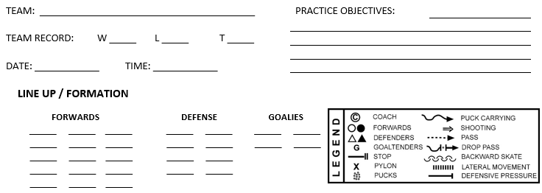

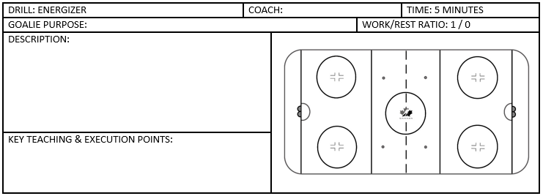

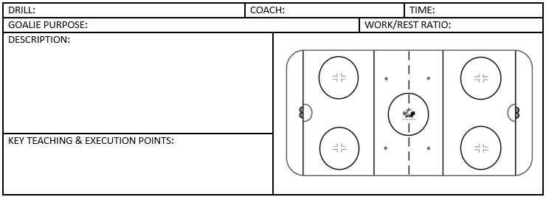

Self-assessment Form
Coach: Start Time: Finish Time:
Team/Level: Date:
Rating Scale:
3 – Above Expectations, 2 – Met Expectations, 1 – Below Expectations, N/A – Not Applicable
Pre-Practice Preparation
Objectives  - Have identified specific technical and tactical objectives | 3 2 1 N/A
Organization  - Pre-ice presentation, prep of assistants  - Equipment required | 3 2 1 N/A
Practice Outline  - Clear, organized, diagrams, warm-up and cool-down, related to objectives | 3 2 1 N/A
Components of Yearly Plan  - Practice plan fits into yearly plan  - Objectives and drill progressions relate to previous practice | 3 2 1 N/A
Practice
Use of Drills  - Full participation  - Teach skills and tactics effectively  - Use drill progressions from simple to complex | 3 2 1 N/A
Teaching Techniques  - Allowed time for teaching and demo  - Demonstrations effective  - Effective use of voice and body language | 3 2 1 N/A
Error Correction  - Immediate and appropriate feedback  - Repetition of drills where necessary | 3 2 1 N/A
Rapport with Players  - Positive communicator  - Non-threatening, relaxed environment  - Evidence of player enjoyment | 3 2 1 N/A
Organization  - Used full ice when necessary and appropriate  - Attention to risk management  - Follow practice outline  - Use of on-ice assistants – support personnel | 3 2 1 N/A
3 Things that went well: | 3 Things to improve on:

Practice 2: Goals and Objectives for the Practice

Self-assessment Form
Coach: Start Time: Finish Time:
Team/Level: Date:
Rating Scale:
3 – Above Expectations, 2 – Met Expectations, 1 – Below Expectations, N/A – Not Applicable
Pre-Practice Preparation
Objectives  - Have identified specific technical and tactical objectives | 3 2 1 N/A
Organization  - Pre-ice presentation, prep of assistants  - Equipment required | 3 2 1 N/A
Practice Outline  - Clear, organized, diagrams, warm-up and cool-down, related to objectives | 3 2 1 N/A
Components of Yearly Plan  - Practice plan fits into yearly plan  - Objectives and drill progressions relate to previous practice | 3 2 1 N/A
Practice
Use of Drills  - Full participation  - Teach skills and tactics effectively  - Use drill progressions from simple to complex | 3 2 1 N/A
Teaching Techniques  - Allowed time for teaching and demo  - Demonstrations effective  - Effective use of voice and body language | 3 2 1 N/A
Error Correction  - Immediate and appropriate feedback  - Repetition of drills where necessary | 3 2 1 N/A
Rapport with Players  - Positive communicator  - Non-threatening, relaxed environment  - Evidence of player enjoyment | 3 2 1 N/A
Organization  - Used full ice when necessary and appropriate  - Attention to risk management  - Follow practice outline  - Use of on-ice assistants – support personnel | 3 2 1 N/A
3 Things that went well: | 3 Things to improve on:

Practice 3: Goals and Objectives for the Practice

Self-assessment Form
Coach: Start Time: Finish Time:
Team/Level: Date:
Rating Scale:
3 – Above Expectations, 2 – Met Expectations, 1 – Below Expectations, N/A – Not Applicable
Pre-Practice Preparation
Objectives  - Have identified specific technical and tactical objectives | 3 2 1 N/A
Organization  - Pre-ice presentation, prep of assistants  - Equipment required | 3 2 1 N/A
Practice Outline  - Clear, organized, diagrams, warm-up and cool-down, related to objectives | 3 2 1 N/A
Components of Yearly Plan  - Practice plan fits into yearly plan  - Objectives and drill progressions relate to previous practice | 3 2 1 N/A
Practice
Use of Drills  - Full participation  - Teach skills and tactics effectively  - Use drill progressions from simple to complex | 3 2 1 N/A
Teaching Techniques  - Allowed time for teaching and demo  - Demonstrations effective  - Effective use of voice and body language | 3 2 1 N/A
Error Correction  - Immediate and appropriate feedback  - Repetition of drills where necessary | 3 2 1 N/A
Rapport with Players  - Positive communicator  - Non-threatening, relaxed environment  - Evidence of player enjoyment | 3 2 1 N/A
Organization  - Used full ice when necessary and appropriate  - Attention to risk management  - Follow practice outline  - Use of on-ice assistants – support personnel | 3 2 1 N/A
3 Things that went well: | 3 Things to improve on:

Complete an Emergency Action Plan
Task #1
Written Assignment
As you prepare for the season, you realize that one Emergency Action Plan (EAP) is not enough. At least one facility your teams plays in will need an EAP that’s different from the one you created for your home facility.
Develop and submit the following to the Field Evaluator:
- A one- or two-page EAP specific to a facility that you are not completely familiar with that specifies:
- The location of telephones, exits, first aid kit, and automated external defibrillator (AED)
- Emergency telephone numbers
- Directions to the activity site; this may include a map or a list of key instructions
- The location of medical profiles for each athlete under your care
- The designated Charge Person, Call Person, and Control Person

A template has been provided on the next page; however, you may use your own format for this EAP.

Task #2
Field Evaluation
Develop and submit the following to the Field Evaluator BEFORE they observe your practice:
- An EAP of your home practice facility that specifies:
- The location of telephones, exits, first aid kit, and AED
- Emergency telephone numbers
- Directions to the activity site; this may include a map or a list of key instructions
- The location of medical profiles for each athlete under your care
- The designated Charge Person, Call Person, and Control Person

A template has been provided on the next page; however, you may use your own format for this EAP.

An Emergency Action Plan for Hockey

