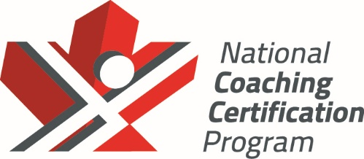

Hockey Canada
Development 1:
Coach Workbook — In-class Component
Version 1, 2025



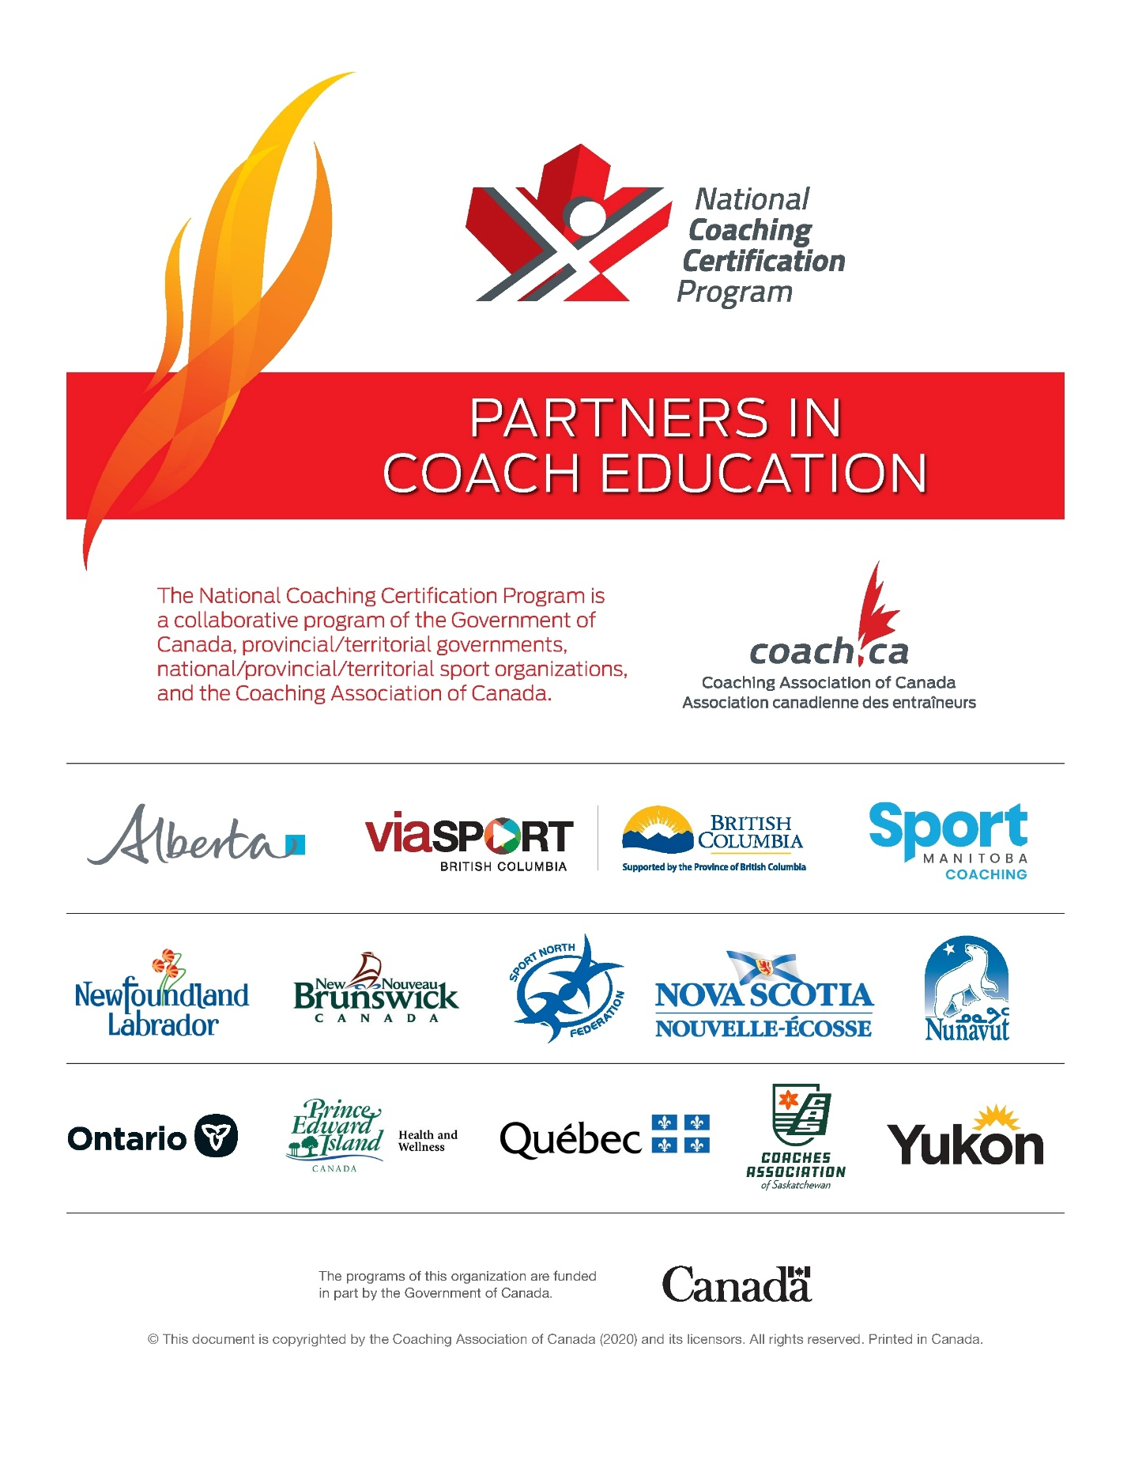

Table of Contents
Introduction 3
Your coach workbook 4
Hockey Canada Network app 5
Preparing to plan 6
Seasonal planning: Introduction 7
Follow-along 8
Hockey Canada coaching downloads 10
Technical skills 11
Follow-along 12
Hockey Canada coaching downloads 18
Individual tactics 19
Follow-along 20
Hockey Canada coaching downloads 24
Team tactics 25
Follow-along 26
Hockey Canada coaching downloads 30
Transition 31
Follow-along 32
More information 34
Goaltending 37
Follow-along 38
Hockey Canada coaching downloads 42
Planning to teach 43
Drill design and progression 44
Follow-along… 45
Hockey Canada coaching downloads 54
Practice design and on-ice prep 55
Follow-along… 56
Hockey Canada coaching downloads 64
Seasonal planning: Tying it all together 65
Follow-along... 66
More information 68
Hockey Canada coaching downloads 78

List of workbook tasks
Preparing to plan 6
Technical skills 11
Task #1: Individual activity, identify skills and errors in video 16
Individual tactics 19
Task #1: Group activity, identify individual tactic and component technical skills 23
Team tactics 25
Task #1: Group activity, identify team tactics and component skills and tactics 29
Transition 31
Task #1: Group activity, discuss how to incorporate transition in existing drills 33
Planning to teach 43
Drill design and progression 44
Task #1: Group activity, design and deliver a drill 47
Task #2: Group activity, design a 3-drill progression 50
Practice design and on-ice prep 55
Task #1: Group activity, design a practice 58
Task #2: Group activity, prepare to deliver a practice 63
Seasonal planning: Tying it all together 65
Task #1: Group activity, discuss the benefits of seasonal plan 67

Introduction

Your coach workbook
Welcome to the in-class component of your Development 1 training!
This workbook is for you to use during your in-class clinic. The workbook contains all the tasks your Learning Facilitator will assign during the in-class component, as well as material that will help you complete those tasks.
The workbook is organized in terms of the 9 modules in the in-class component:

The workbook presents some or all of the following information for each module:
- Follow-along: The text of the slides your Learning Facilitator presents. This helps you follow along at the time and also serves as a reminder of the clinic’s content that you can refer to later.
- Tasks: The tasks you complete during the clinic. These are in the Follow-along parts of the workbook right where your Learning Facilitator assigns them.
- More information: Supplementary information such as examples that will help you complete your tasks.
- Hockey Canada coaching downloads: Links to additional information on each module’s topic. You do NOT need to master this material to become certified as a Development 1 coach. It is, however, valuable information in and of itself, and understanding it will help make you a better coach.
- Tools: Forms and resources such as templates you can use in your own coaching.

Hockey Canada Network app
The Hockey Canada Network App is a free download.
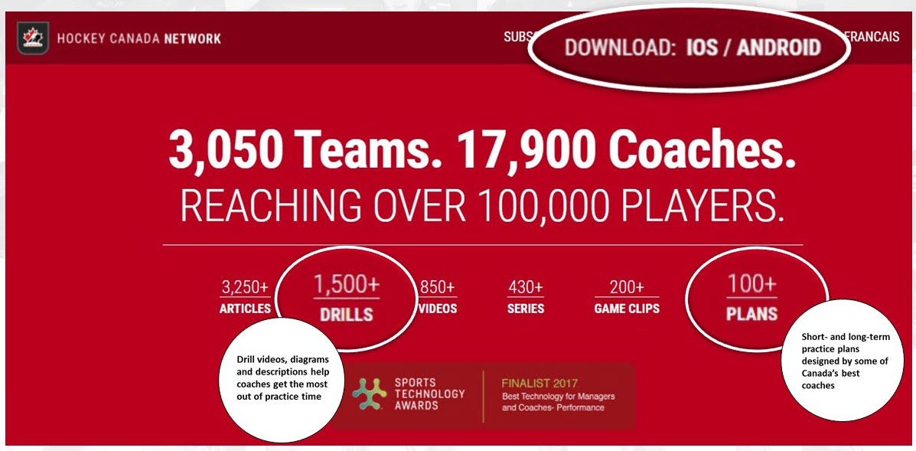
To find out more, check out https://www.hockeycanadanetwork.com/.

Preparing to plan

Seasonal planning: Introduction
In this section:
- Follow-along
- Hockey Canada coaching downloads

Follow-along

Long Term Player Development model
NCCP/Sport for Life | Hockey Canada
NCCP Competition – Development
Sport for Life Train to Compete  MALE 16 - 17 and FEMALE 16 - 18 NATIONAL  During this stage players will participate in training with a focus on position specific technical and tactical preparation. There is as emphasis on fitness preparation and the development of position specific technical and tactical skills under competitive conditions. Important objectives are the development of aerobic capacity, power, self awareness and independence. The player may be introduced to international competitive experience at the end of this stage. | Hockey Canada Coach 2 Coach Level (Recreational)  Hockey Canada Development 1 (Competitive)  HP1 (national competition)  Instructional Stream 3
Sport for Life Train to Train  MALE 12 - 16 and FEMALE 11 - 15 PROVINCIAL  The focus during this stage is on building an aerobic base, developing speed and strength and further developing and consolidating sport specific technical skills with an increased emphasis on hockey and a reduction in the number of other sports played. This phase will also include the introduction and development of individual and group tactics. Social and emotional considerations are addressed by placing an emphasis on team-building, group interaction and social activities. | Hockey Canada Coach 2 Coach Level (Recreational)  Hockey Canada Development 1 (Competitive)  HP1 (provincial competition)  Instructional Stream 2
NCCP Competition – Introduction
Sport for Life Learn to Train  MALE 11 - 12 and FEMALE 10 - 11 LOCAL / PROVINCIAL  This is the most significant period for development. This is the window of accelerated adaptation to motor coordination. Group interaction, team building and social activities should be emphasized. A reasonable balance of practices and games will foster the ongoing development and mastery of essential skills in hockey. | Hockey Canada Coach 2 Coach Level (Recreational)  Hockey Canada Development 1 (Competitive)  Instructional Stream 2
Sport for Life Learn to Play
MALE 9 - 10 and FEMALE 8 - 9 LOCAL
This stage is the beginning of the most important window to develop the fine motor skills on an individual technical skill basis that leads to utilizing these skills into individual and team tactics later on. During this phase, prior to the beginning of the growth spurt, players have the best opportunity to learn and begin to master fine motor skills that can be used in combination with other skills. In most cases what is learned or not learned in this stage will have a very significant effect on the level of play that is achieved later on. Players should be able to begin to transfer skills and concepts from practices to games.

What is a seasonal plan?
- A plan of all team activities, events, and development
- In hockey, the ‘seasonal plan’ is really a series of plans rather than a single plan. For example, we make decisions about scouting and recruiting, player evaluation, training, technical and tactical play, fitness, and so on. Collectively, these map out our intentions for training and for competition.

What are the benefits of planning?
- Where are we now?
- Where do we want to be?
- How are we going to get there?
- Provides focus and direction
- Provides structure but must stay flexible

Periods and phases
- What are the three periods of a seasonal plan?
- What are the phases within each period?
There are 3 periods in a seasonal plan… | And phases within the periods…
Preparation | Tryout  Development
Competition | Regular season  Playoff
Transition | The transition period usually isn’t divided into smaller units like phases. Generally, the transition period occurs after the last competition of the season. It’s a time for physical, mental, emotional, and social recuperation.  In Development 1, we are not focusing on the transition period, which turns a seasonal plan into a Yearly Training Plan.

What are key components of a seasonal plan?
- # of practices
- # of games
- Technical/Tactical
- Physical prep
- Mental prep
- Team development

Hockey Canada coaching downloads
Check Hockey Canada’s coaching downloads for these resources on seasonal planning:
- Long Term Player Development model
- Seasonal planning: Additional resources

Technical skills
In this section:
- Follow-along
- Task #1
- Hockey Canada coaching downloads

Follow-along

Hockey development pyramid
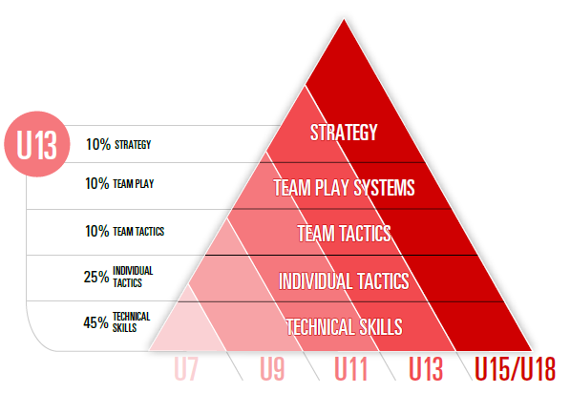
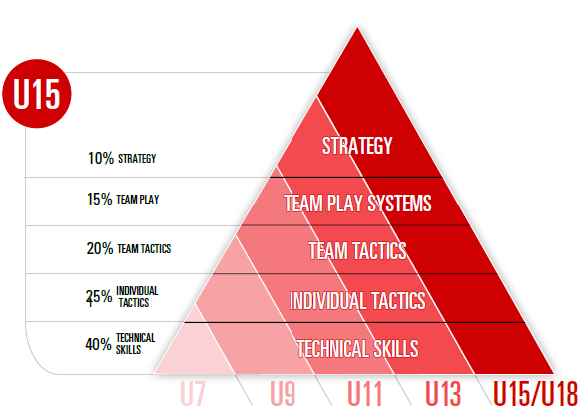
- Technical skills are the foundation for all other things to come — individual tactics, team tactics, transition, etc.

Hockey’s technical skills
- 5 categories of technical skills:
- Skating
- Puck control
- Passing / Receiving
- Shooting
- Checking

Inventory – U13 – Technical skills
Technical skills | Skating | Puck control | Passing/Receiving | Shooting | Checking | Goaltending
Technical skills | Balance and agility  Edge control  Starting and stopping  Forward skating and striding  Backward skating  Turning and crossovers | Stationary  Moving | Stationary  Moving | Forehand ‐ wrist shot  Backhand ‐ shot  Forehand/backhand shots in motion  Forehand ‐ flip shot  Backhand ‐ flip shot  Tips/Deflections  Snap/Slap shot | Skating/Agility  Angling/Positioning  Stick checks | Skating  Hands  Slides  Rebound control
Tactical skills | Individual offensive tactics |  | Individual defensive tactics |  | Team tactics
Tactical skills | Body fakes/shot fakes  Stick fakes/fake pass  Dekes  Moves in combination  Net drives  Change of pace  Puck protection  Control skating  Saving ice |  | Angling  Basic 1 on 1’s  Gap control  Escape moves  Puck retrievals  Tracking |  | Basic positioning – D Zone  Basic breakouts  Regroups  Entries  Forechecks
Other | Physical prep |  | Mental prep |  | Team development
Other | Warm-up and cool-down  Testing (on-ice and off-ice)  Conditioning  Nutrition & hydration  Recovery |  | Goal-setting  Positive self-talk |  | Team building  Player meetings  Parent meetings  Admin
Note: This inventory is included in the U13 seasonal plan.
Inventory – U15/18 – Technical skills
Technical skills | Skating | Puck control | Passing/Receiving | Shooting | Checking | Goaltending
Technical skills | Agility/Balance  Edge control  Forward skating  Backward skating  Turning  Crossovers  Transition and pivots  Quickness | Stationary  Moving  Small-area skills  Agility  Puck protection  Creativity | Stationary  Moving  Puck support | Stationary  Moving  1-timers  Quick release  Shooting fakes  Changing puck angle  Shooting off pass  Forehand to backhand/Backhand to forehand  Shooting for sticks | Skating/Agility  Angling/Positioning  Stick checks  Body contact  Body checking | Balance and agility  Moving skills  Positioning  Save selection  Basic puck control  Advanced skating  Eye skills  Advanced hands  Advanced puck handling  10 scoring situations  Defensive team play  Offensive team play  Hockey sense
Tactical skills | Individual offensive tactics |  | Individual defensive tactics |  | Team tactics
Tactical skills | Attacking 1 on 1  Shaking a defender 1 on 1  Screening without the puck |  | Defending 1 on 1  Defending in the corner  Defending along the boards  Backchecking |  | Offensive: Entries, offensive zone play  Defensive: Defensive zone coverage, breakouts  Special team: PP breakouts, PP setup, PK forecheck, PK in the DZ  Forechecking: Offensive zone, neutral zone  Transition/Regroups: Neutral zone play  Face-offs: Techniques, OZ/DZ face-offs
Other | Physical prep |  | Mental prep |  | Team development
Other | Warm-up and cool-down  Testing (on-ice and off-ice)  Conditioning  Nutrition & hydration  Recovery |  | Imagery  Goal-setting  Positive self-talk  Relaxation |  | Team building  Player meetings  Parent meetings  Admin
Note: This inventory is included in the U15/18 seasonal plan.

Skill analysis
As a group, watch the video on stick handling that the Learning Facilitator plays and identify the skills being worked on in the clip.
- Note that this is not just stick handling — it’s heel-to-heel skating, head up, edge control/work, etc.

Skill analysis
- As a group, watch the game clip that the Learning Facilitator plays and identify the skills players are using in the clip.

Task #1
Watch the video the Learning Facilitator shows, and then complete the table below, using the Analyze Technical Skills Tool on the next page as a guide:
- For both players, write down all the technical skills you see them using.
- For both players, identify one error, and suggest one (or more) corrective measures.
This player… | Used these skills… | Made this error… | I suggest this corrective measure(s)
#1

#2

Analyze technical skills tool
For this skill… | Look for…
Skating | ☐ Acceleration  ☐ Speed  ☐ Mobility  ☐ Agility  ☐ Balance  ☐ Stride  ☐ Crossovers  ☐ Pivots  ☐ Acceleration out of turns  ☐ Quick feet  ☐ Controlled skating  ☐ Change of pace.
Puck control | ☐ Head up  ☐ Smooth and quiet  ☐ Good hands  ☐ Protection  ☐ In small spaces  ☐ In traffic
Passing/Receiving | ☐ Passing  ☐ Receiving  ☐ Passing choices  ☐ On backhand  ☐ Unselfish with the puck  ☐ Presents a good target  ☐ Receives and retains with control  ☐ Touch passing
Shooting | ☐ Power  ☐ Accuracy  ☐ Quick release  ☐ Can shoot in motion  ☐ Goal scorer  ☐ Rebounder  ☐ Variety of shots
Checking | ☐ Concept of angling  ☐ Good body position with balance and control  ☐ Defensive side position  ☐ Aggressive checker  ☐ Strength  ☐ Taking checks
Note: This tool is available on the Hockey Canada coaching downloads page.

Hockey Canada coaching downloads
Check Hockey Canada’s coaching downloads for these resources on technical skills:
- Technical skills: Additional resources

Individual tactics
In this section:
- Follow-along
- Task #1
- Hockey Canada coaching downloads

Follow-along

What is an individual tactic?
- An action that combines 2 or more individual skills to gain an offensive or defensive advantage

Hockey development pyramid

Individual tactics – U13
- Individual tactics are defined as offensive when either the player or the team has the puck, as defensive when neither the player nor the team has the puck
- See the inventories for U13 and U15/18 on the next two pages for the individual tactics appropriate for these age groups

Inventory – U13 – Tactical skills
Technical skills | Skating | Puck control | Passing/Receiving | Shooting | Checking | Goaltending
Technical skills | Balance and agility  Edge control  Starting and stopping  Forward skating and striding  Backward skating  Turning and crossovers | Stationary  Moving | Stationary  Moving | Forehand ‐ wrist shot  Backhand ‐ shot  Forehand/backhand shots in motion  Forehand ‐ flip shot  Backhand ‐ flip shot  Tips/Deflections  Snap/Slap shot | Skating/Agility  Angling/Positioning  Stick checks | Skating  Hands  Slides  Rebound control
Tactical skills | Individual offensive tactics |  | Individual defensive tactics |  | Team tactics
Tactical skills | Body fakes/shot fakes  Stick fakes/fake pass  Dekes  Moves in combination  Net drives  Change of pace  Puck protection  Control skating  Saving ice |  | Angling  Basic 1 on 1’s  Gap control  Escape moves  Puck retrievals  Tracking |  | Basic positioning – D Zone  Basic breakouts  Regroups  Entries  Forechecks
Other | Physical prep |  | Mental prep |  | Team development
Other | Warm-up and cool-down  Testing (on-ice and off-ice)  Conditioning  Nutrition & hydration  Recovery |  | Goal-setting  Positive self-talk |  | Team building  Player meetings  Parent meetings  Admin
Note: This inventory is included in the U13 seasonal plan.
Inventory – U15/18 – Tactical skills
Technical skills | Skating | Puck control | Passing/Receiving | Shooting | Checking | Goaltending
Technical skills | Agility/Balance  Edge control  Forward skating  Backward skating  Turning  Crossovers  Transition and pivots  Quickness | Stationary  Moving  Small-area skills  Agility  Puck protection  Creativity | Stationary  Moving  Puck support | Stationary  Moving  1-timers  Quick release  Shooting fakes  Changing puck angle  Shooting off pass  Forehand to backhand/Backhand to forehand  Shooting for sticks | Skating/Agility  Angling/Positioning  Stick checks  Body contact  Body checking | Balance and agility  Moving skills  Positioning  Save selection  Basic puck control  Advanced skating  Eye skills  Advanced hands  Advanced puck handling  10 scoring situations  Defensive team play  Offensive team play  Hockey sense
Tactical skills | Individual offensive tactics |  | Individual defensive tactics |  | Team tactics
Tactical skills | Attacking 1 on 1  Shaking a defender 1 on 1  Screening without the puck |  | Defending 1 on 1  Defending in the corner  Defending along the boards  Backchecking |  | Offensive: Entries, offensive zone play  Defensive: Defensive zone coverage, breakouts  Special team: PP breakouts, PP setup, PK forecheck, PK in the DZ  Forechecking: Offensive zone, neutral zone  Transition/Regroups: Neutral zone play  Face-offs: Techniques, OZ/DZ face-offs
Other | Physical prep |  | Mental prep |  | Team development
Other | Warm-up and cool-down  Testing (on-ice and off-ice)  Conditioning  Nutrition & hydration  Recovery |  | Imagery  Goal-setting  Positive self-talk  Relaxation |  | Team building  Player meetings  Parent meetings  Admin
Note: This inventory is included in the U15/18 seasonal plan.

Individual tactics – Game application
- Watch the video to see how players combine techniques in games to create skills and ultimately individual tactics

Task #1
As a group, watch the video your Learning Facilitator shows, and then use the space below to note the following:
- The individual offensive or defensive tactic your group decided to wok with: _______________________________
- The definition of the tactic — what is it, when is it used in a game, why is it used?

- The individual skills required to perform the tactic

Hockey Canada coaching downloads
Check Hockey Canada’s coaching downloads for resources on individual tactics.

Team tactics
In this section:
- Follow-along
- Task #1
- Hockey Canada coaching downloads

Follow-along

What is a team tactic?
- An action by 2 or 3 players that combines two or more individual tactics to gain an offensive or defensive advantage

Team tactics – U13
- See the inventories for U13 and U15/18 on the next two pages for the team tactics appropriate for these age groups

Inventory – U13 – Team tactics
Technical skills | Skating | Puck control | Passing/Receiving | Shooting | Checking | Goaltending
Technical skills | Balance and agility  Edge control  Starting and stopping  Forward skating and striding  Backward skating  Turning and crossovers | Stationary  Moving | Stationary  Moving | Forehand ‐ wrist shot  Backhand ‐ shot  Forehand/backhand shots in motion  Forehand ‐ flip shot  Backhand ‐ flip shot  Tips/Deflections  Snap/Slap shot | Skating/Agility  Angling/Positioning  Stick checks | Skating  Hands  Slides  Rebound control
Tactical skills | Individual offensive tactics |  | Individual defensive tactics |  | Team tactics
Tactical skills | Body fakes/shot fakes  Stick fakes/fake pass  Dekes  Moves in combination  Net drives  Change of pace  Puck protection  Control skating  Saving ice |  | Angling  Basic 1 on 1’s  Gap control  Escape moves  Puck retrievals  Tracking |  | Basic positioning – D Zone  Basic breakouts  Regroups  Entries  Forechecks
Other | Physical prep |  | Mental prep |  | Team development
Other | Warm-up and cool-down  Testing (on-ice and off-ice)  Conditioning  Nutrition & hydration  Recovery |  | Goal-setting  Positive self-talk |  | Team building  Player meetings  Parent meetings  Admin
Note: This inventory is included in the U13 seasonal plan.
Inventory – U15/18 – Team tactics
Technical skills | Skating | Puck control | Passing/Receiving | Shooting | Checking | Goaltending
Technical skills | Agility/Balance  Edge control  Forward skating  Backward skating  Turning  Crossovers  Transition and pivots  Quickness | Stationary  Moving  Small-area skills  Agility  Puck protection  Creativity | Stationary  Moving  Puck support | Stationary  Moving  1-timers  Quick release  Shooting fakes  Changing puck angle  Shooting off pass  Forehand to backhand/Backhand to forehand  Shooting for sticks | Skating/Agility  Angling/Positioning  Stick checks  Body contact  Body checking | Balance and agility  Moving skills  Positioning  Save selection  Basic puck control  Advanced skating  Eye skills  Advanced hands  Advanced puck handling  10 scoring situations  Defensive team play  Offensive team play  Hockey sense
Tactical skills | Individual offensive tactics |  | Individual defensive tactics |  | Team tactics
Tactical skills | Attacking 1 on 1  Shaking a defender 1 on 1  Screening without the puck |  | Defending 1 on 1  Defending in the corner  Defending along the boards  Backchecking |  | Offensive: Entries, offensive zone play  Defensive: Defensive zone coverage, breakouts  Special team: PP breakouts, PP setup, PK forecheck, PK in the DZ  Forechecking: Offensive zone, neutral zone  Transition/Regroups: Neutral zone play  Face-offs: Techniques, OZ/DZ face-offs
Other | Physical prep |  | Mental prep |  | Team development
Other | Warm-up and cool-down  Testing (on-ice and off-ice)  Conditioning  Nutrition & hydration  Recovery |  | Imagery  Goal-setting  Positive self-talk  Relaxation |  | Team building  Player meetings  Parent meetings  Admin
Note: This inventory is included in the U15/18 seasonal plan.

Team tactics – Game application
- Watch the video to see how players execute tactics in a game

Task #1
As a group, watch the video your Learning Facilitator shows, and then use the space below to note the following:
- The team tactic your group decided to work with: _______________________________
- The definition of the tactic — what is it, when is it used in a game, why is it used?

- The individual skills and individual tactics required to perform the team tactic.

Hockey Canada coaching downloads
Check Hockey Canada’s coaching downloads for resources on team tactics.

Transition
In this section:
- Follow-along
- Task #1
- More information

Follow-along

Principles of play
Offensive play | Defensive play
Pressure  Puck control  Support  Transition | Pressure  Stall/Contain  Support  Transition

What is transition?
- Movement of a team from offence to defence or defence to offence

Transition – Example
- Watch the clip to see how a team goes from defence to offence and then from offence to defence
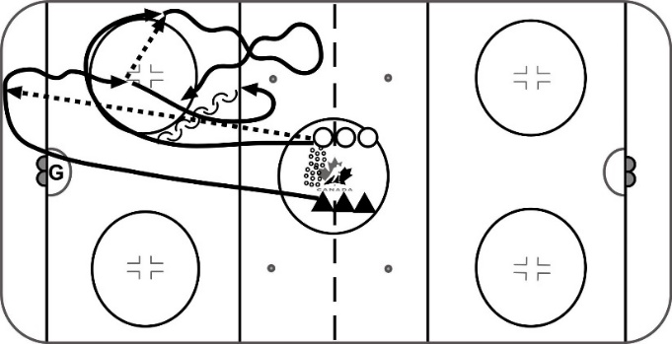
Individual tactics – Breakout 1 on 1
- Gap drill. Forward dumps pucks and defence retrieves and breaks out the forward
- F up ice and turns back for a 1-1
- D must close gap and play the 1-1
- Coaches need to decide if players will challenge in the neutral zone and “jump” the forward or be passive, pivot, and defend the middle of the ice
- Pressure
- Contain
Key teaching points
- Forwards want to hustle up ice and create some space to attack; use good individual tactics to challenge the defence
- D needs to gap up and decide whether to 1) close the gap and “jump” the forward before they get turned or 2) defend the middle of the ice and pivot and contain; the decision may depend on each situation and on team philosophy

Team transition
- Watch the examples of teams going from offence to defence and then defence to offence in both the offensive and defensive zone

Task #1
Watch the examples of players transitioning from offence to defence to offence and then discuss how to incorporate the principle of transition into existing drills:
- Don’t stop on the whistle. Have D retrieve the puck off a rebound and skate up the ice.
- The play does not stop at the net or on a whistle. Let the D and the forward play it out. There are multiple opportunities to transition from offensive to defensive to offensive, etc.
- At the end of a rush defence, the D have to start the breakout for the next rep.
- At the end of a shooting drill rep, the shooter has to retrieve the puck that the goalie has directed to the corner.
- In a DZone drill (e.g., 2v2 low) when the defenders get possession, they have to break the puck out.
- In a backcheck drill when the play gets broken up, the defenders have to get the puck to the backcheckers, and the attackers now backcheck.

More information

1 on 2 cross ice game
- The idea is for O to carry the puck through the middle of the ice with control
- F1 should be trying to separate O from the puck and/or angling the puck carrier to the boards
- F2 should support and be prepared to jump on a loose puck or separate O from the puck
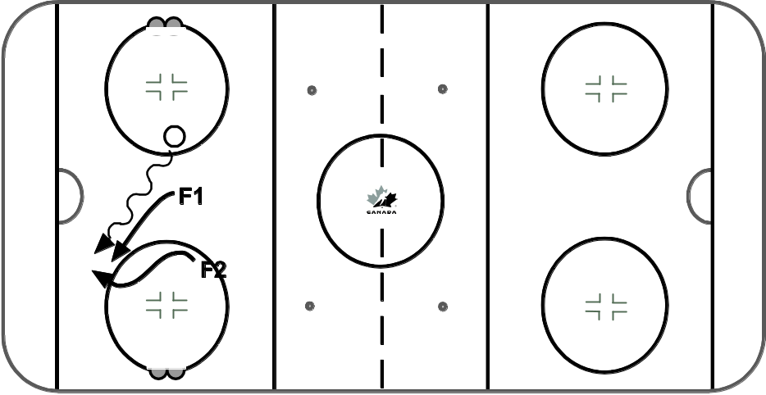
- F2 should carry to the middle of the ice with control, drop to F1 and screen or block O
- F1 must support behind puck carrier
- O should be defending and trying to keep F1 and F2 to the outside
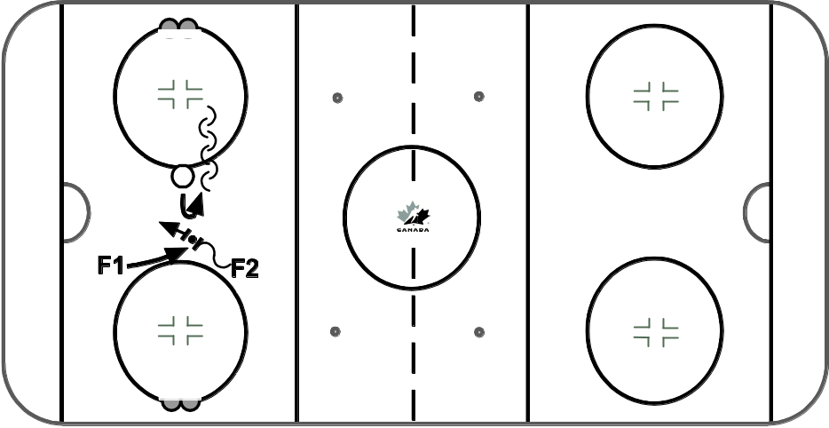

2 vs 1 – One-puck drill (in 1 end)
- Forwards have 2 objectives - to score and forecheck
- Defence has 3 objectives - prevent scoring, gain possession of puck, make breakout pass to next group of F's.
- Goalie starts with the puck and passes to F1. F1 skates to middle and passes to F2. F1 and F2 regroup to attack D1 2 on 1.
- D1 moves, reads and closes the gap to play the 2 on 1
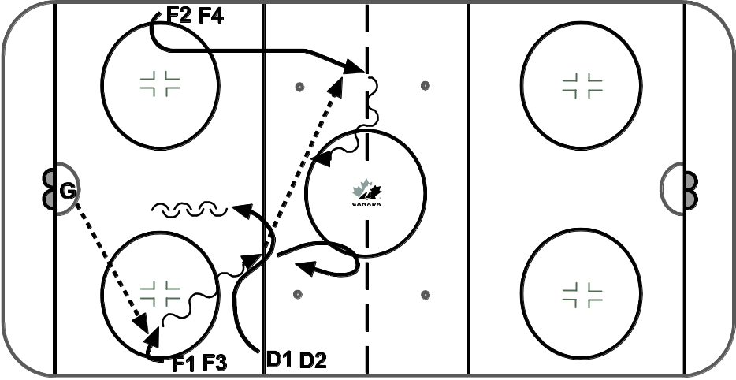
- F1 and F2 try to score or forecheck in order to try to score again. F1 and F2 play 2 on 1 against D1 below the dotes. If the puck comes outside the dots O or X can control. D1 must gain possession of puck to pass to X or O, when O or X have control they clear zone and attack on D2. If the D or the goalie can't clear the zone in 20 seconds the coach blows the whistle and X and O start drill over.
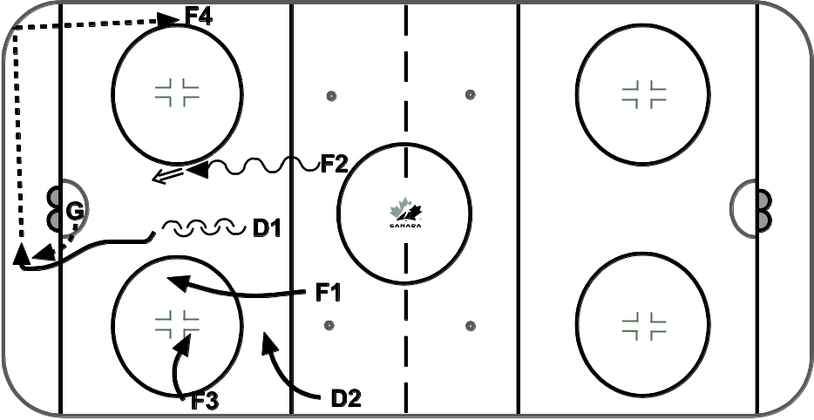

1 vs 2 – Using two nets (in 1 end)
- Forwards have 3 objectives: to score, to control the puck, and to backcheck.
- Defence have 3 objectives: to prevent scoring, to gain possession, and to start the offence by skating with the puck.
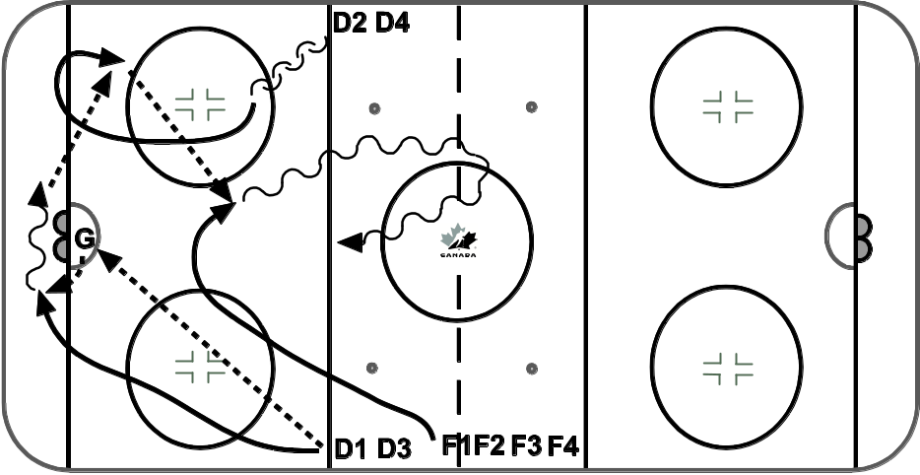
- D1 starts this drill by shooting at the goalkeeper or dumping the puck behind the net. The goalkeeper makes the save and passes to D1 or D2 who then passes to F1 (according to your break out system). Then D1 and D2 skate quickly in the neutral zone, pivot and play 1 vs. 2 against F1. F1 starts the drill at the same time as D1. F1 reads the play and skates with timing to open space for the break out pass. After receiving the pass F1 skates though the centre ice and plays 1 vs. 2.
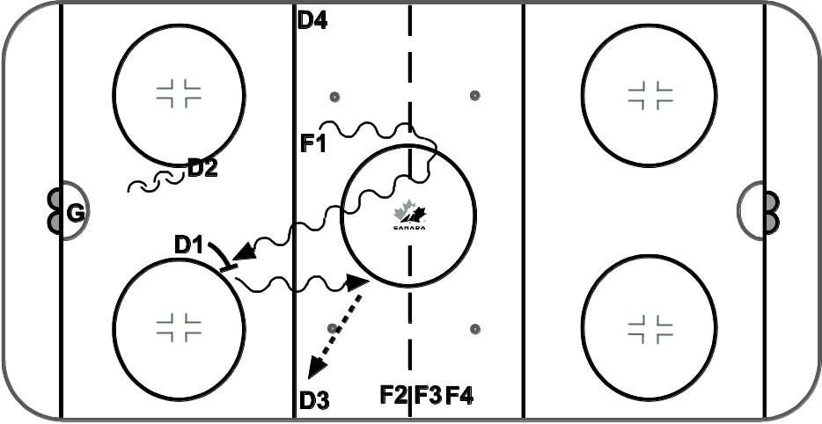
- If F1 scores, then D3 starts the drill over. If D1 or D2 gain possession of the puck to the puck, D1 and D2 play 2vs 1 against F1. D1 and D2 try to carry the puck to the middle of the ice through the neutral zone face off dots which act as the second net.

Goaltending
In this section:
- Follow-along
- Hockey Canada coaching downloads

Follow-along

Introduction
- Incorporate your goalies into each drill. Give them an individual skill or team concept to focus on (goalie purpose).
- Your goalies will improve doing team drills, but if you make time for one drill (10 minutes) per practice, you will be able to give them the attention they deserve.
- There is information on goaltender skills in the Hockey Canada coaching downloads link, but it won’t be discussed in this module — the trend at D1 and HP1 is to access specialized help.
- Goaltending is a critical aspect of team play and requires direct, consistent, and unique coaching skills.
- Just as forwards and defenders get specific coaching for their respective positions, goalies need the same attention and guided skill development.

Pre-save/Save/Post-save
- Goaltending can be broken up into 3 major parts — pre-save, save, and post-save:
- Pre-save: Maintain strong visual connection to the puck while moving into the shot line.
- Save: Make the correct save selection/response to the shot.
- Post-save: Move immediately to the new shot line to best defend the net if a rebound occurs.

The save cycle
- The save cycle consists of 5 key areas of focus for solid goaltending:
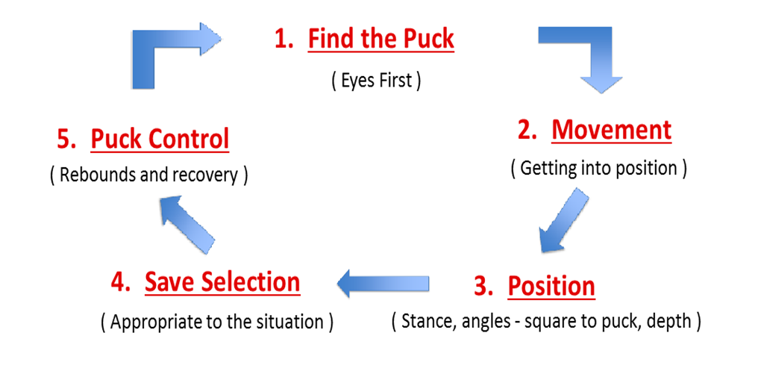

- This is how the save cycle and pre-save/save/post-save are related:
Save cycle | Pre-save/Save/Post-save
#1, Find the puck  #2, Movement  #3, Position | Pre-save
#4, Save selection | Save
#5, Puck control | Post-save

Ten scoring situations
- Hockey Canada’s goaltender advisory group identified 10 scoring situations that goaltenders and coaches need to be aware of.
- The scoring situations are broken down into 10 categories to help the goaltender recognize the situation and select the best way to defend it.
- Goaltenders must be able to read both attacking players’ options and their own teammates’ defending position while processing the situation.
- The 10 scoring situations are:
- Clear shots
- Entries
- Net drives
- Breakaways
- Rebounds
- Low/High
- East/West
- Below the goal line
- Deflections
- Screens

Practice tips
- Skating: Goaltenders’ priorities should be goalie-specific skating (“C” cuts, T-push, shuffles and pivots); when not doing these, they should join in team skating drills for conditioning.
- Passing: Goaltenders should focus on goalie-specific passing drills when the team is doing passing drills.
- Drills: Explain to goalies the purpose of the drills for them and their role in the drills.
- Plan to have 3 or 4 coaches at practice. Whenever your goalies have some idle time, a 3rd or 4th coach can be a great deal of help.
- Space out your shooters.
- Use game-application drills.

Team warm-up drill:
Goalie purpose – skating
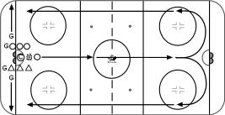

Team warm-up drill:
Goalie purpose – feel the puck 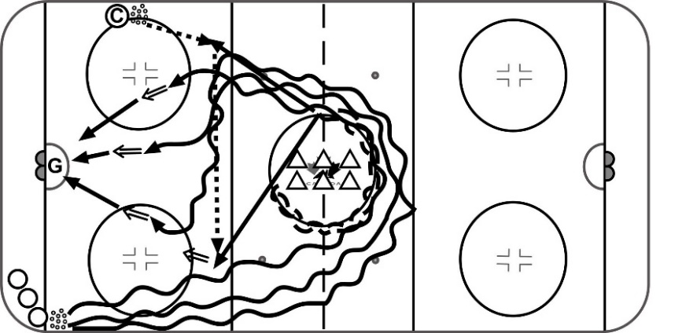

Team drill:
Goalie purpose – puck handling 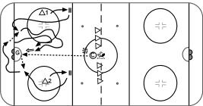

Communication:
Goaltenders / Goalie Coach
- Communicate who is playing the next game
- Give your goaltenders a minimum of one practice (if available) to mentally prepare for their next start
- Explain what is expected of them in game situations
- Be sure that expectations align with individual and team goals
- Give feedback
- Be open and honest, and try to provide feedback that is quantifiable, e.g., stats
- Set goals
- Set individual and team goals

The role of the goalie coach
- Goalie coaches will be most effective when encouraged to do the following:
- Design and implement drills
- Act as a liaison between the goaltenders and the head coach
- Help goaltenders with mental preparation and routine
- Assess game and practice performance to identify strengths and areas for development
- Use video as an effective coaching tool
- Help goaltenders deal with pressure and poor performances

Hockey Canada coaching downloads
Check Hockey Canada’s coaching downloads for these resources on goaltending:
- Goaltending: Additional resources

Planning to teach

Drill design and progression
In this section:
- Follow-along
- Task #1
- Task #2
- Hockey Canada coaching resources

Follow-along…

Design and deliver a drill
- Four steps:
- Step 1: Select the skill or tactic to be taught and explain its purpose
- Step 2: Define 1 or 2 key teaching points
- Step 3: Create a clear diagram of the drill with a description
- Step 4: Deliver/teach the drill

Design a drill
- Step 1: Select the skill or tactic to be taught and explain its purpose
- Is age and level appropriate
- Fits with seasonal plan
- Has a “why”
- Step 2: Define 1 or 2 key teaching points
- Key teaching points (KTPs) provide a teaching focus for each drill
- Too many KTPs create overload…young players can only process 2-3 things at a time
- Feedback and corrections should be based on KTPs

Design a drill
- Step 3: Create a clear diagram of the drill with a description
- This involves using a drill-design template to document your drills
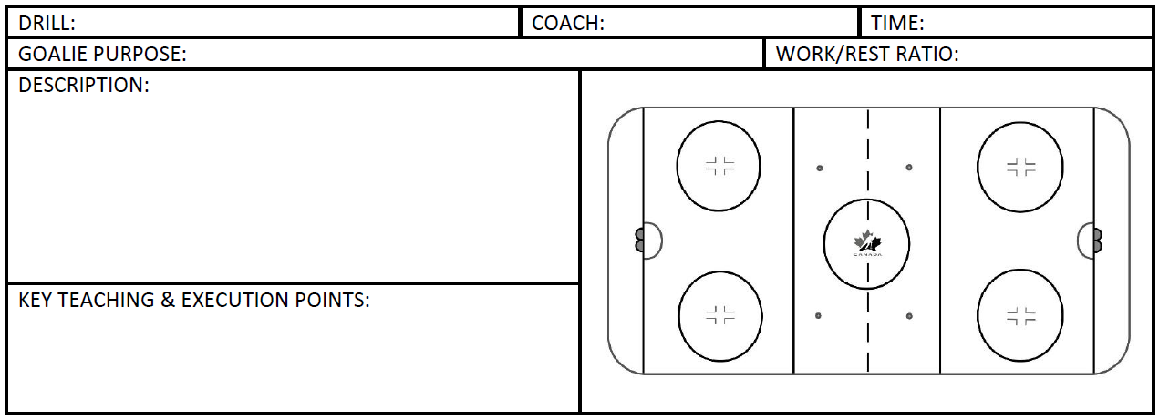

Step 4: Deliver/teach the drill
- Decide how to demonstrate the drill
- Plan and allow for feedback
Drill design: Example 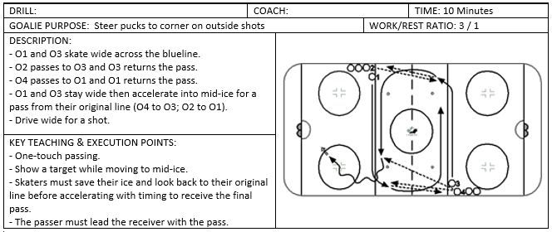

Task #1
In your assigned group, use the drill-design template below to design and deliver a drill for a technical skill or individual tactic. This involves following the 4-step process for designing and delivering a drill introduced earlier (Design and deliver a drill, page 51).
Drill: | Coach: |  |  | Time:
Goalie purpose: |  |  | Work/rest ratio:
Description: |  | 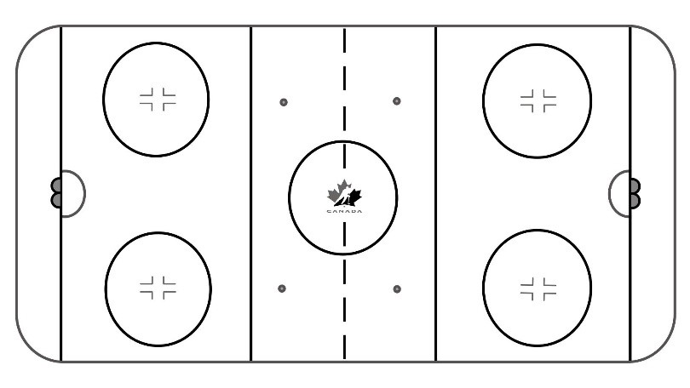
Key teaching & execution points:

Note: This is the starting point for designing drills and practices.

Drill progression
- What is a drill progression?
- The process of increasing the complexity of a drill in a logical manner

Progression: 3 phases
- Introduction
- Teaching the skill in a controlled environment
- Blocked drills, no decision making or creativity
- More focused on technique
- Development
- Reviewing, refining, and practising the skill to develop proficiency
- Using the technique in an applicable skill
- Random drills, some pressure, some decision making and thinking
- Application
- Specificity that simulates game application
- Drills contain pressure, decision making, problem solving
- Drills have an objective, and the players have to determine how to achieve it

Progression: Example of Introduction phase for an individual skill
- Skill – Transition skating
- Heels first
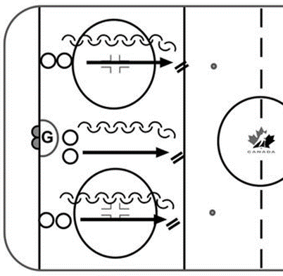
- Players focus on heels-first transition from forward to backward
- Toes first
- Players focus on toes-first transition from forward to backward
- Ride inside edge
- Players focus on transition, which allows an aggressive gap but also the possibility of containing

Progression: Example of Development phase for an individual skill
- Skill – Transition skating
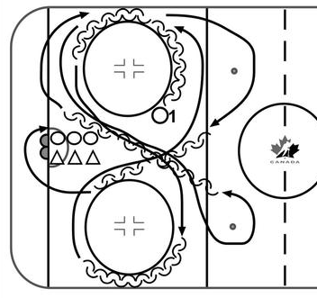

Progression: Example of Application phase for an individual skill
- Skill – Transition skating
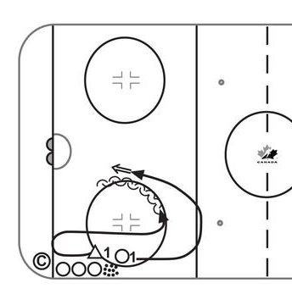

Task #2
In your assigned group, use the 3 drill-design templates below to design a 3-drill progression to introduce, develop, and apply an individual tactic for the technical skill or individual tactic you used in Task #1 (page 53).
Drill #1
Drill: | Coach: |  |  | Time:
Goalie purpose: |  |  | Work/rest ratio:
Description:

Key teaching & execution points:

Drill #2
Drill: | Coach: |  |  | Time:
Goalie purpose: |  |  | Work/rest ratio:
Description:

Key teaching & execution points:

Drill #3
Drill: | Coach: |  |  | Time:
Goalie purpose: |  |  | Work/rest ratio:
Description:

Key teaching & execution points:

Food for thought
- Concepts you can introduce when designing drills
- Starting drills with skills
- Starting drills from face-offs
- Retrieving loose-pucks
- Stealing pucks

Hockey Canada coaching downloads
Check Hockey Canada’s coaching downloads for these resources on drill design and progression:
- Drill design and progression: Additional resources

Practice design and on-ice prep
In this section:
- Follow-along
- Task #1
- Task #2
- Hockey Canada coaching downloads

Follow-along…

9 components of a practice plan

Individual components of a practice plan
- Objectives
- Current
- Seasonal plan
- Based on schedule
- Based on individual and/or team performance
- Use of staff
- Instruct
- Demonstrate
- Correct
- Detect
- Praise
- Motivate
- Ice utilization
- Safety
- Specificity
- Goaltender instruction
- Goals of coaching staff
- Repetition
- Pace
- Timing
- Work/rest ratio
- Volume of work
- Energizer
- Cool-down

Individual components of a practice plan cont’d
- Skill development
- Identify skills
- Execution points
- Teaching points
- Repetitions
- Progressions
- Goaltenders
- Skills
- Incorporate in every drill
- Use of equipment
- Safety
- Drill design
- Visual cues
- Whistle
- Teaching and safety
- Instructional content
- Review
- Polish/Mastery
- Methodology
- Feedback
- Fun
- Small-area games
- Competition drills
- Low-organized games

Tips for effective practices
- Appropriate use of whistle
- Use of whiteboard
- Posting/sharing the practice plan
- Reinforcing safety
- Effective group organization (at board, in rink)
- Pre-practice coach meeting
- Pre-icing players before practice
- Proper placement of coaches for feedback/safety
- Post-practice evaluation/debrief (players/coaches)
- Use of technology, Drill Hub, Hockey Canada Network app, etc.

Task #1
In your assigned group, use the drill-design templates on the pages below to design a practice that includes a progression of individual skills, individual tactics, and a related small-area game.

Drill: | Coach: |  |  | Time:
Goalie purpose: |  |  | Work/rest ratio:
Description:

Key teaching & execution points:

Drill: | Coach: |  |  | Time:
Goalie purpose: |  |  | Work/rest ratio:
Description:

Key teaching & execution points:

Drill: | Coach: |  |  | Time:
Goalie purpose: |  |  | Work/rest ratio:
Description:

Key teaching & execution points:

Drill: | Coach: |  |  | Time:
Goalie purpose: |  |  | Work/rest ratio:
Description:

Key teaching & execution points:

Drill: | Coach: |  |  | Time:
Goalie purpose: |  |  | Work/rest ratio:
Description:

Key teaching & execution points:

Drill: | Coach: |  |  | Time:
Goalie purpose: |  |  | Work/rest ratio:
Description:

Key teaching & execution points:

Drill: | Coach: |  |  | Time:
Goalie purpose: |  |  | Work/rest ratio:
Description:

Key teaching & execution points:

Drill: | Coach: |  |  | Time:
Goalie purpose: |  |  | Work/rest ratio:
Description:

Key teaching & execution points:

Task #2
- In your assigned groups, prepare to deliver a 3-drill progression that you will execute on-ice to the larger group.
- Use the 3-drill progression you developed earlier, in Task #2 of the Drill design and progression module.
- Decide on coach responsibilities, etc.

Coach’s notes:

Hockey Canada coaching downloads
Check Hockey Canada’s coaching downloads for these resources on practice design and on-ice prep:
- Hockey Canada practice plan template
- Practice design and on-ice prep: Additional resources

Seasonal planning: Tying it all together
In this section:
- Follow-along
- Task #1
- More information
- Hockey Canada coaching downloads

Follow-along...

Seasonal planning
- Review of a seasonal plan

Seasonal plan – Overview
- Follow along as the Learning Facilitator presents an overview of what one month in a U15/18 seasonal plan looks like
- There’s a 1-page summary for every month with appropriate sections for training elements
- A seasonal plan is a ‘living’ document — adjust it and add supporting details as needed

Seasonal plan – Calendar
- The calendar:
- Lists the number of practices / games
- Identifies different periods and phases
- Indicates specific events on appropriate days of the month

Seasonal plan – Goals
- Set SMART goals for each month.
- Set goals for each training element (i.e., technical / tactical, physical preparation, mental preparation, team development).
- Specific training elements should support progress toward goals

Seasonal plan – Other training elements and evaluation and assessment
- Other training elements
- There are separate boxes for physical preparation, mental preparation, team development.
- List specific items to be trained during the month.
- Evaluation and assessment
- Track progress on specific training elements in support of goals.
- Identify training elements that require additional focus in subsequent months.

Seasonal plan – At-a-Glance
- 3-month snapshot (previous month, current month, next month).
- Specific week number within seasonal plan.
- Phases during each month.

Seasonal plan – Inventory
- Check the final page of the seasonal plan for an inventory of the technical skills, tactical skills, and other training elements to be added to your seasonal plan

Task #1
As a group, discuss and note the importance of using a seasonal plan:
- How will a seasonal plan help you with practice planning?
- How does charting tactics, skills, etc., help you plan your practices?
- How can a seasonal plan help you plan your travel? tournaments? etc.

Coach’s notes:

More information

U13 seasonal plan
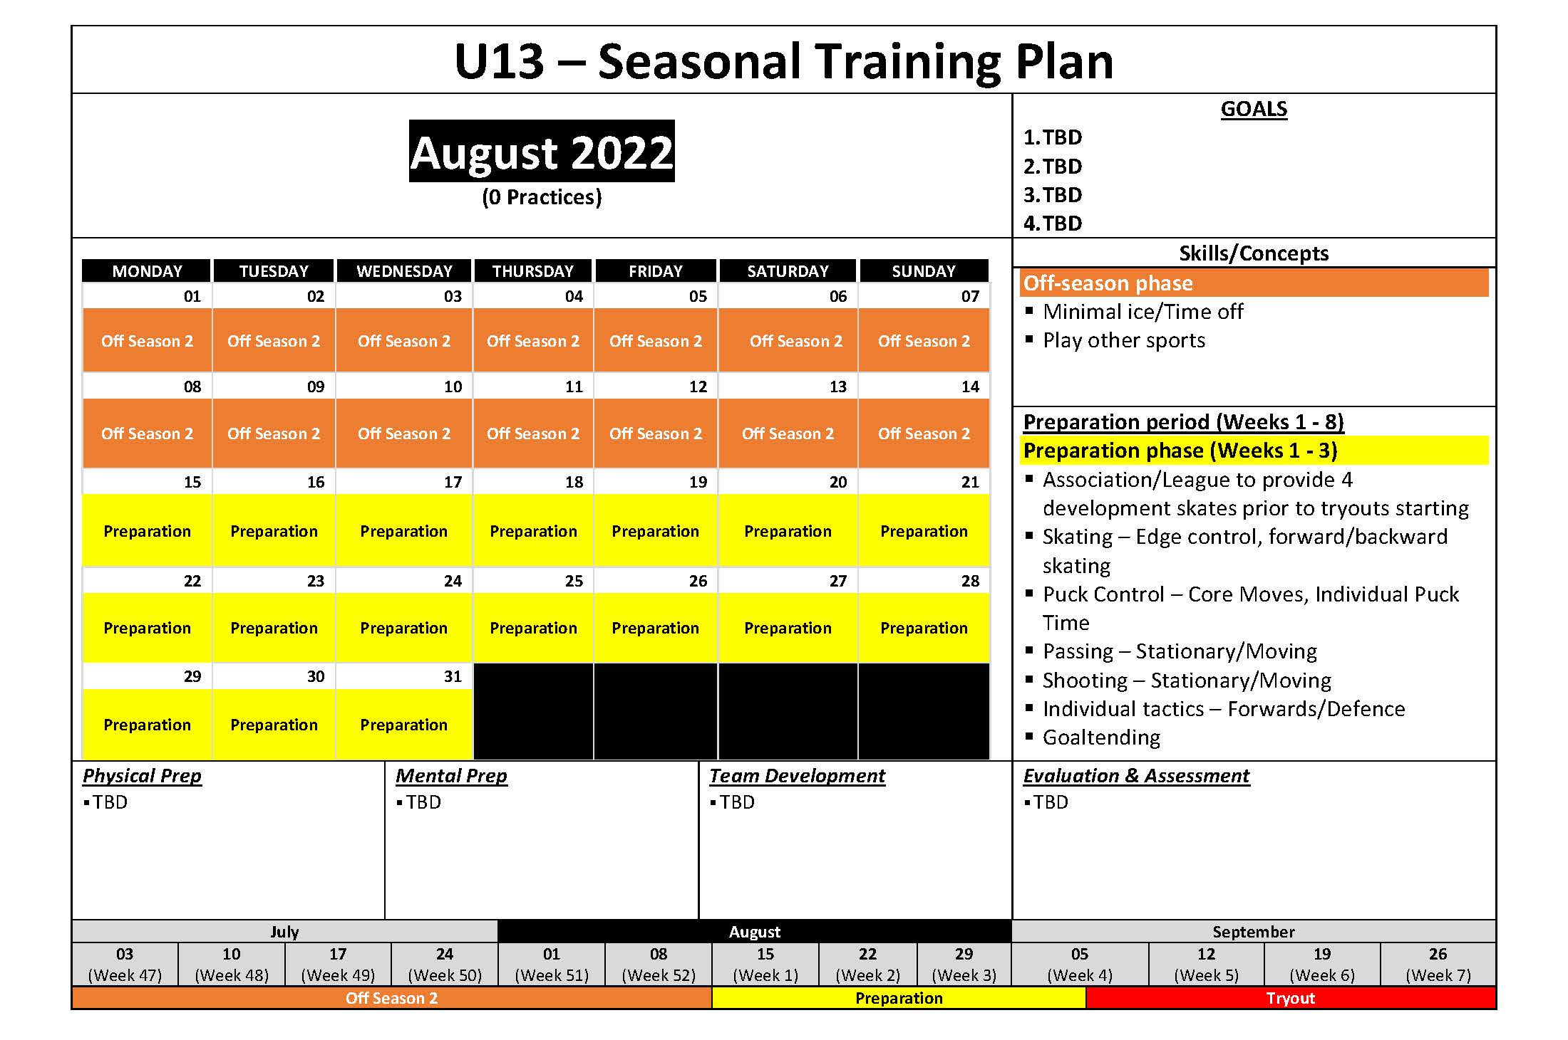

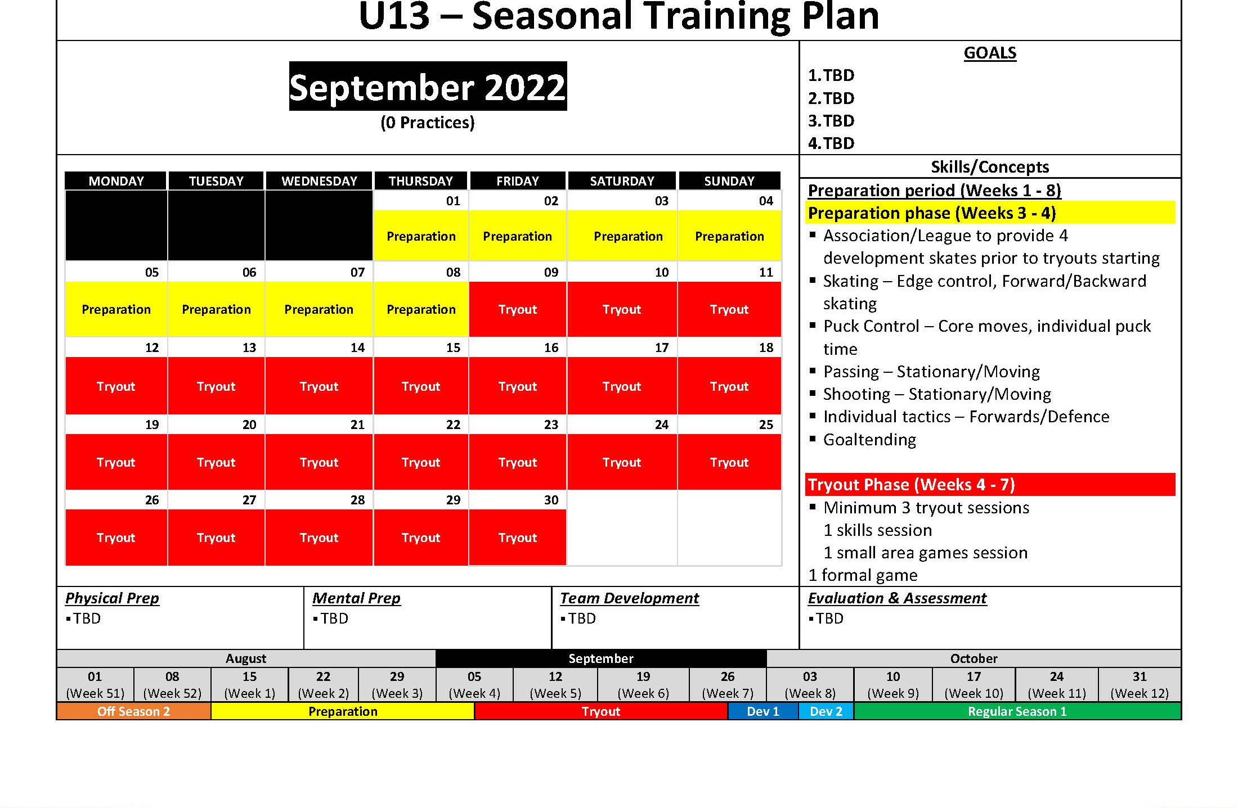

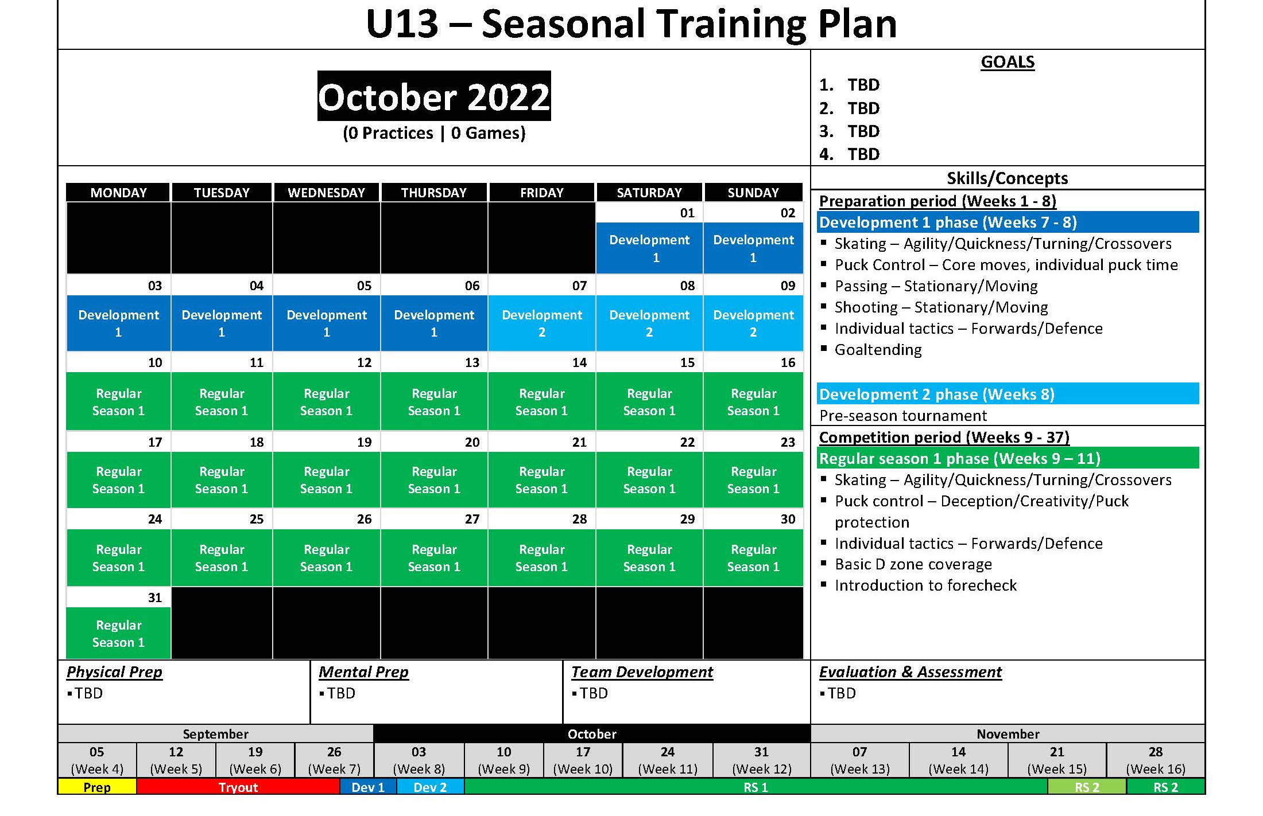

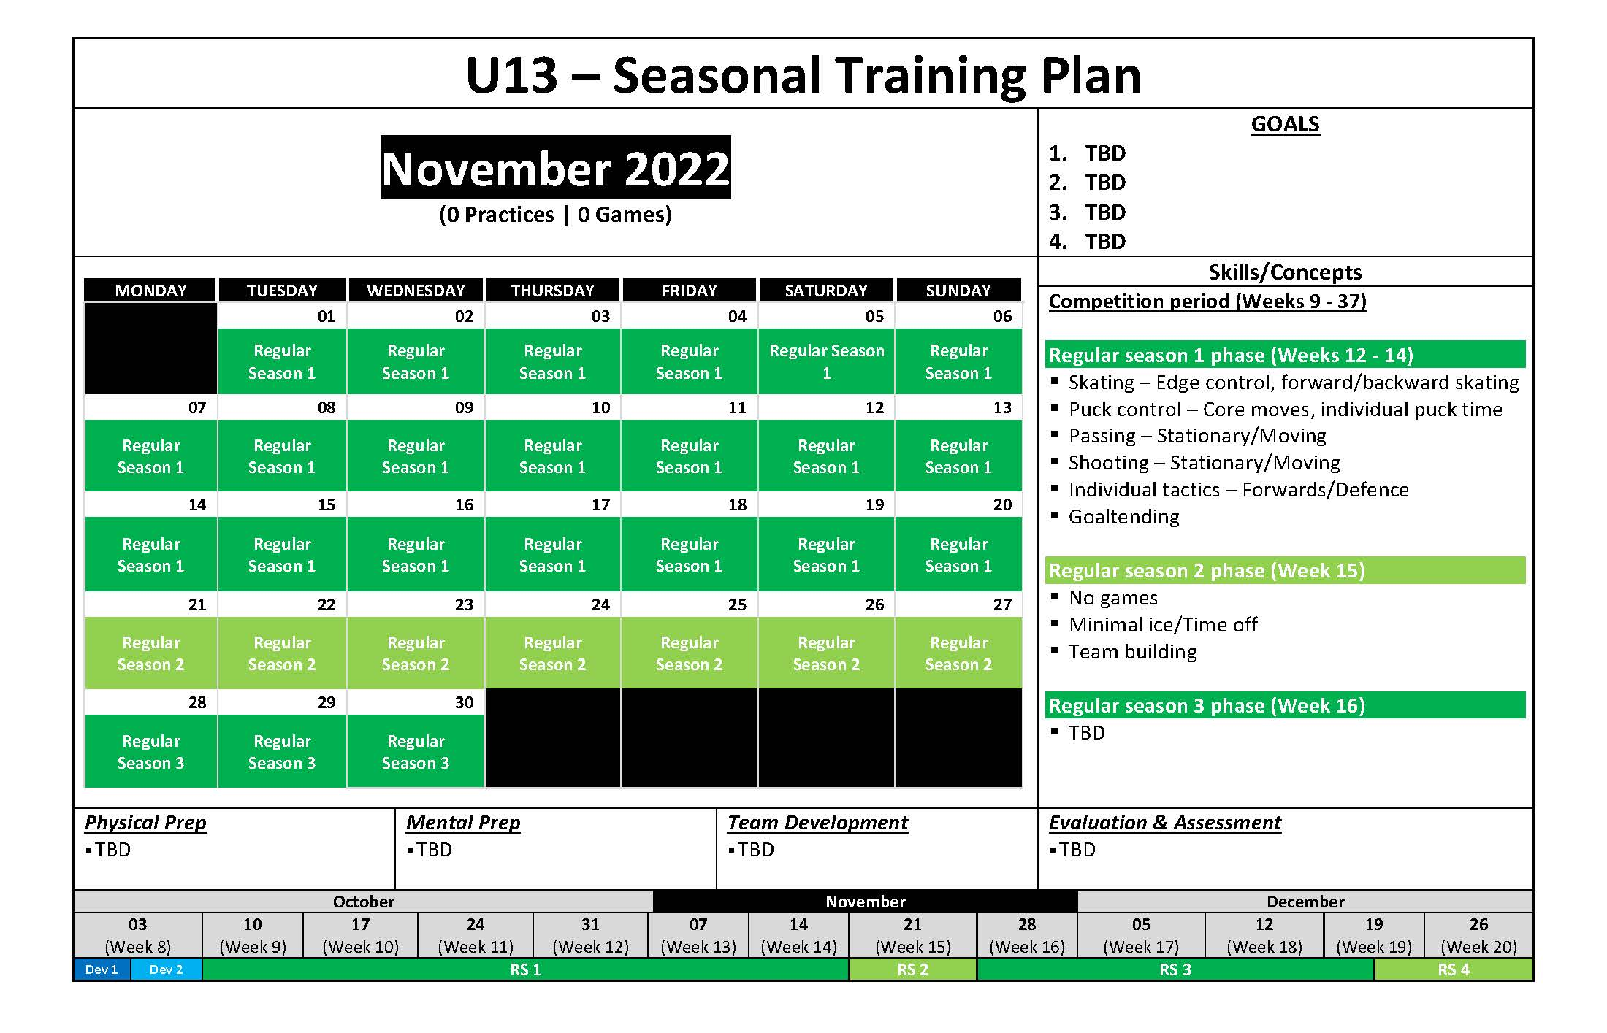

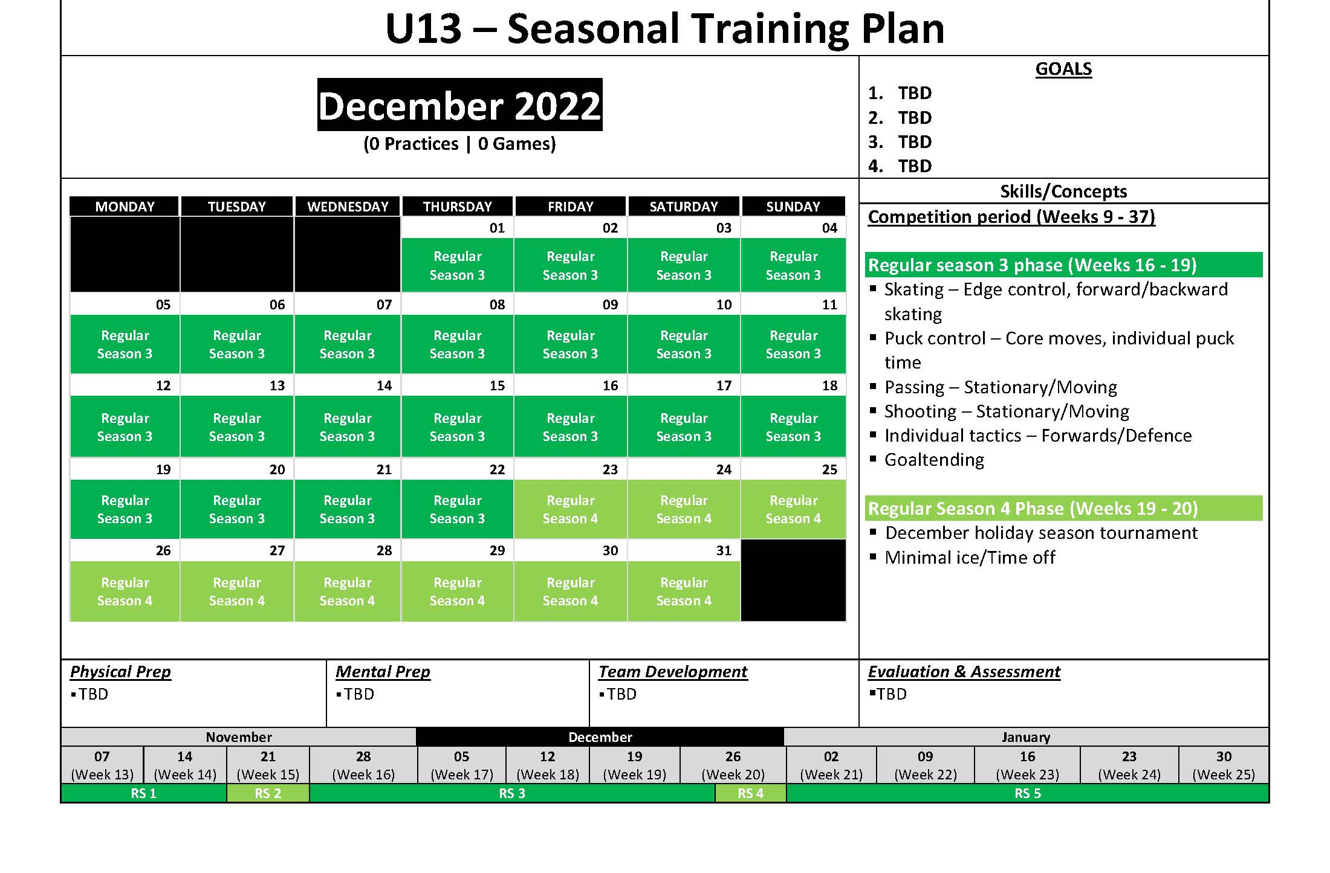

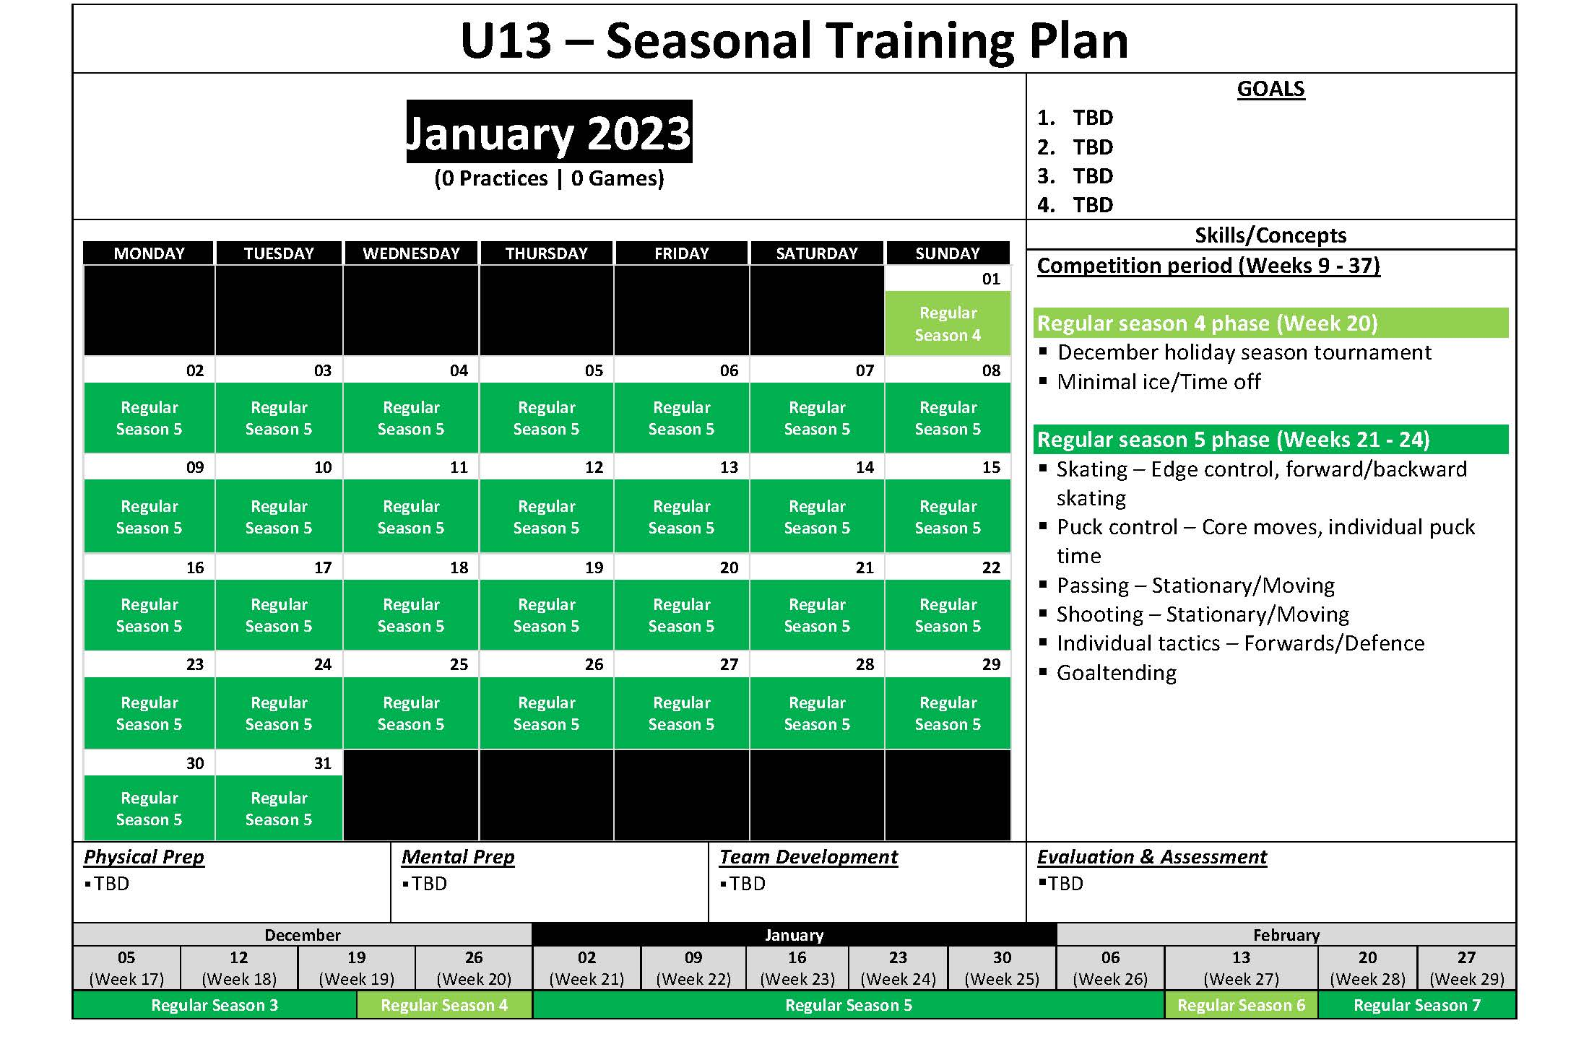

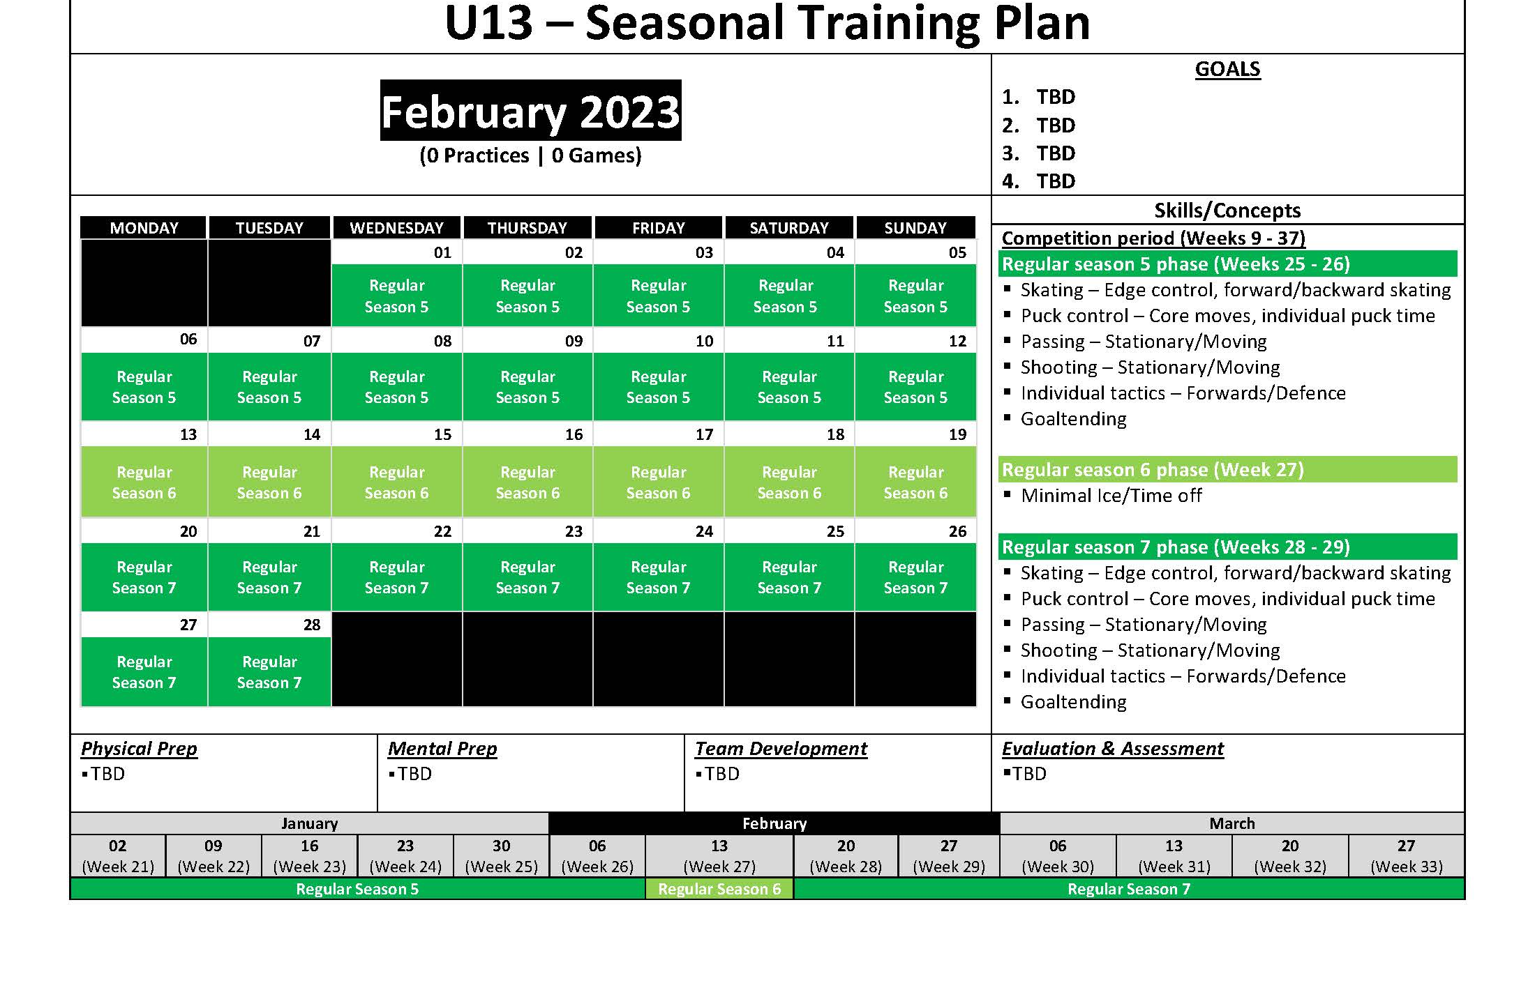

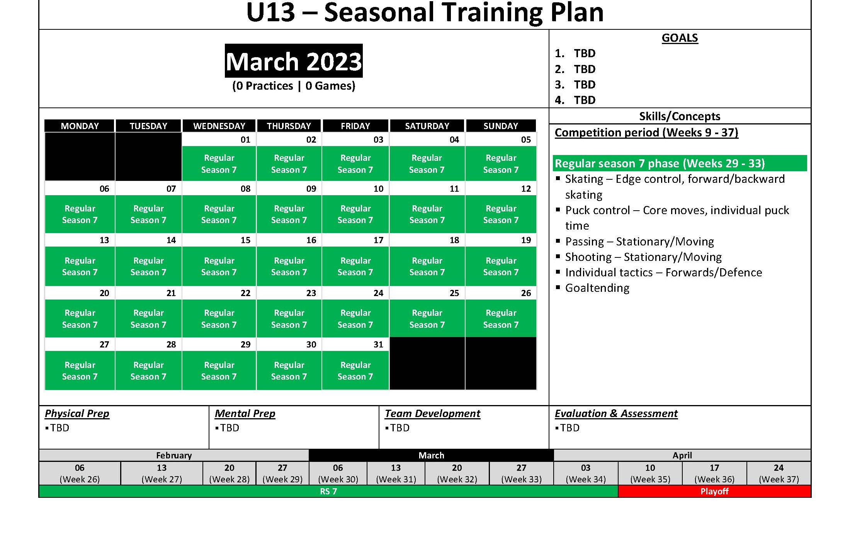
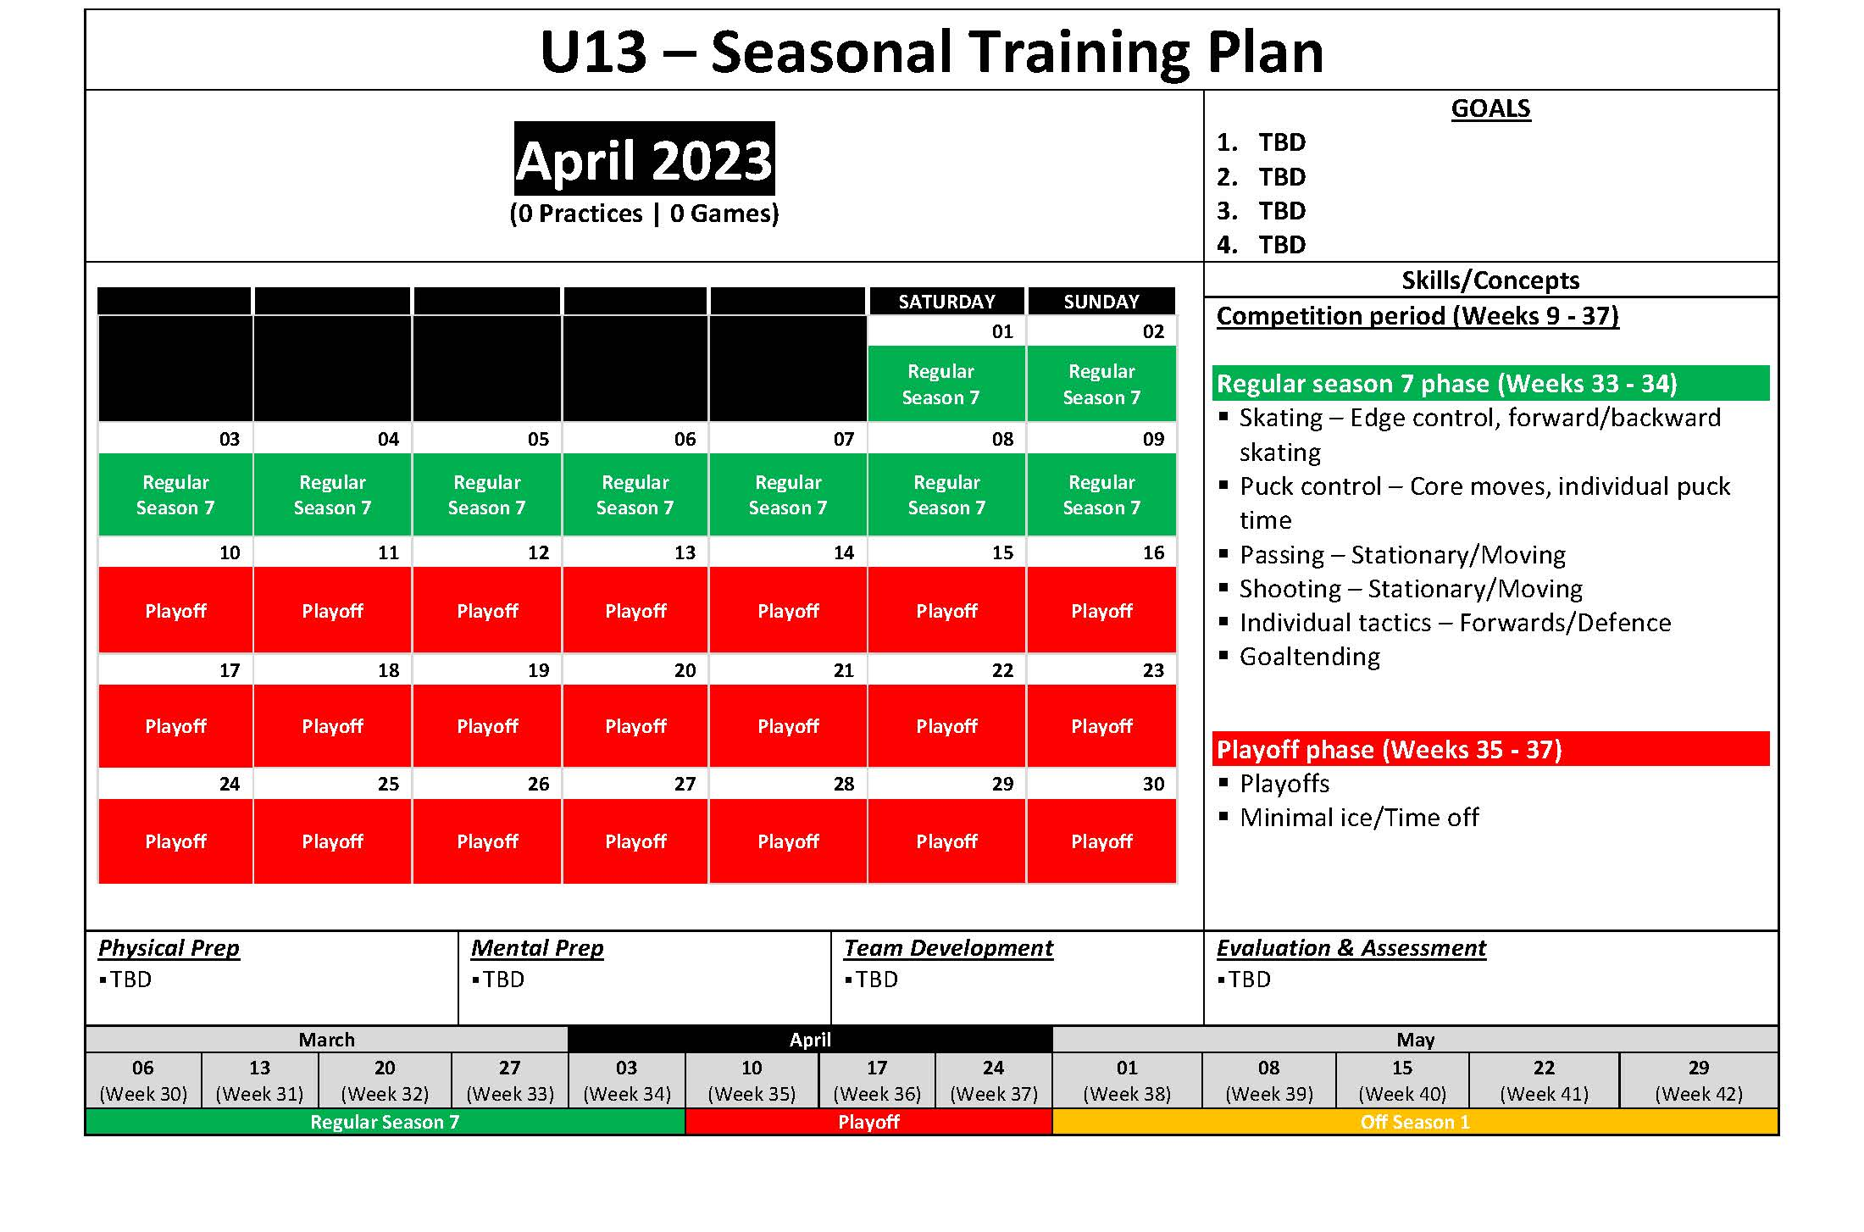

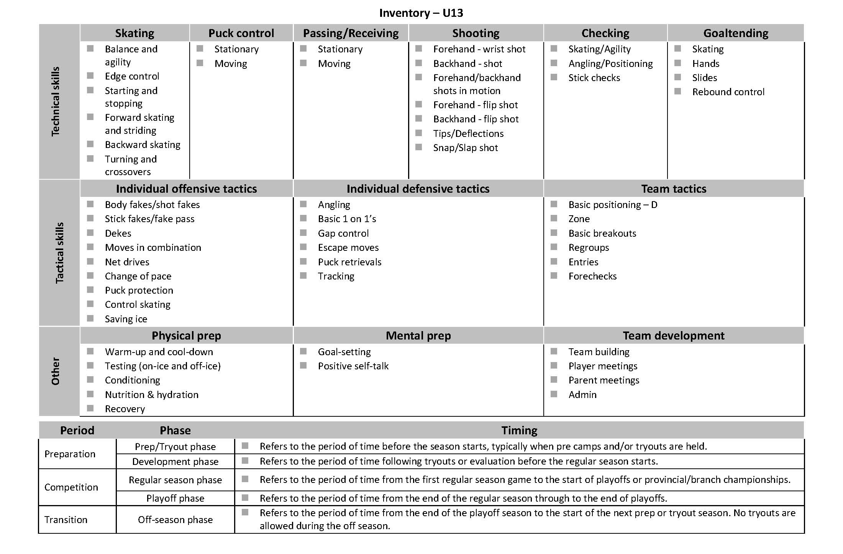

U15/18 seasonal plan
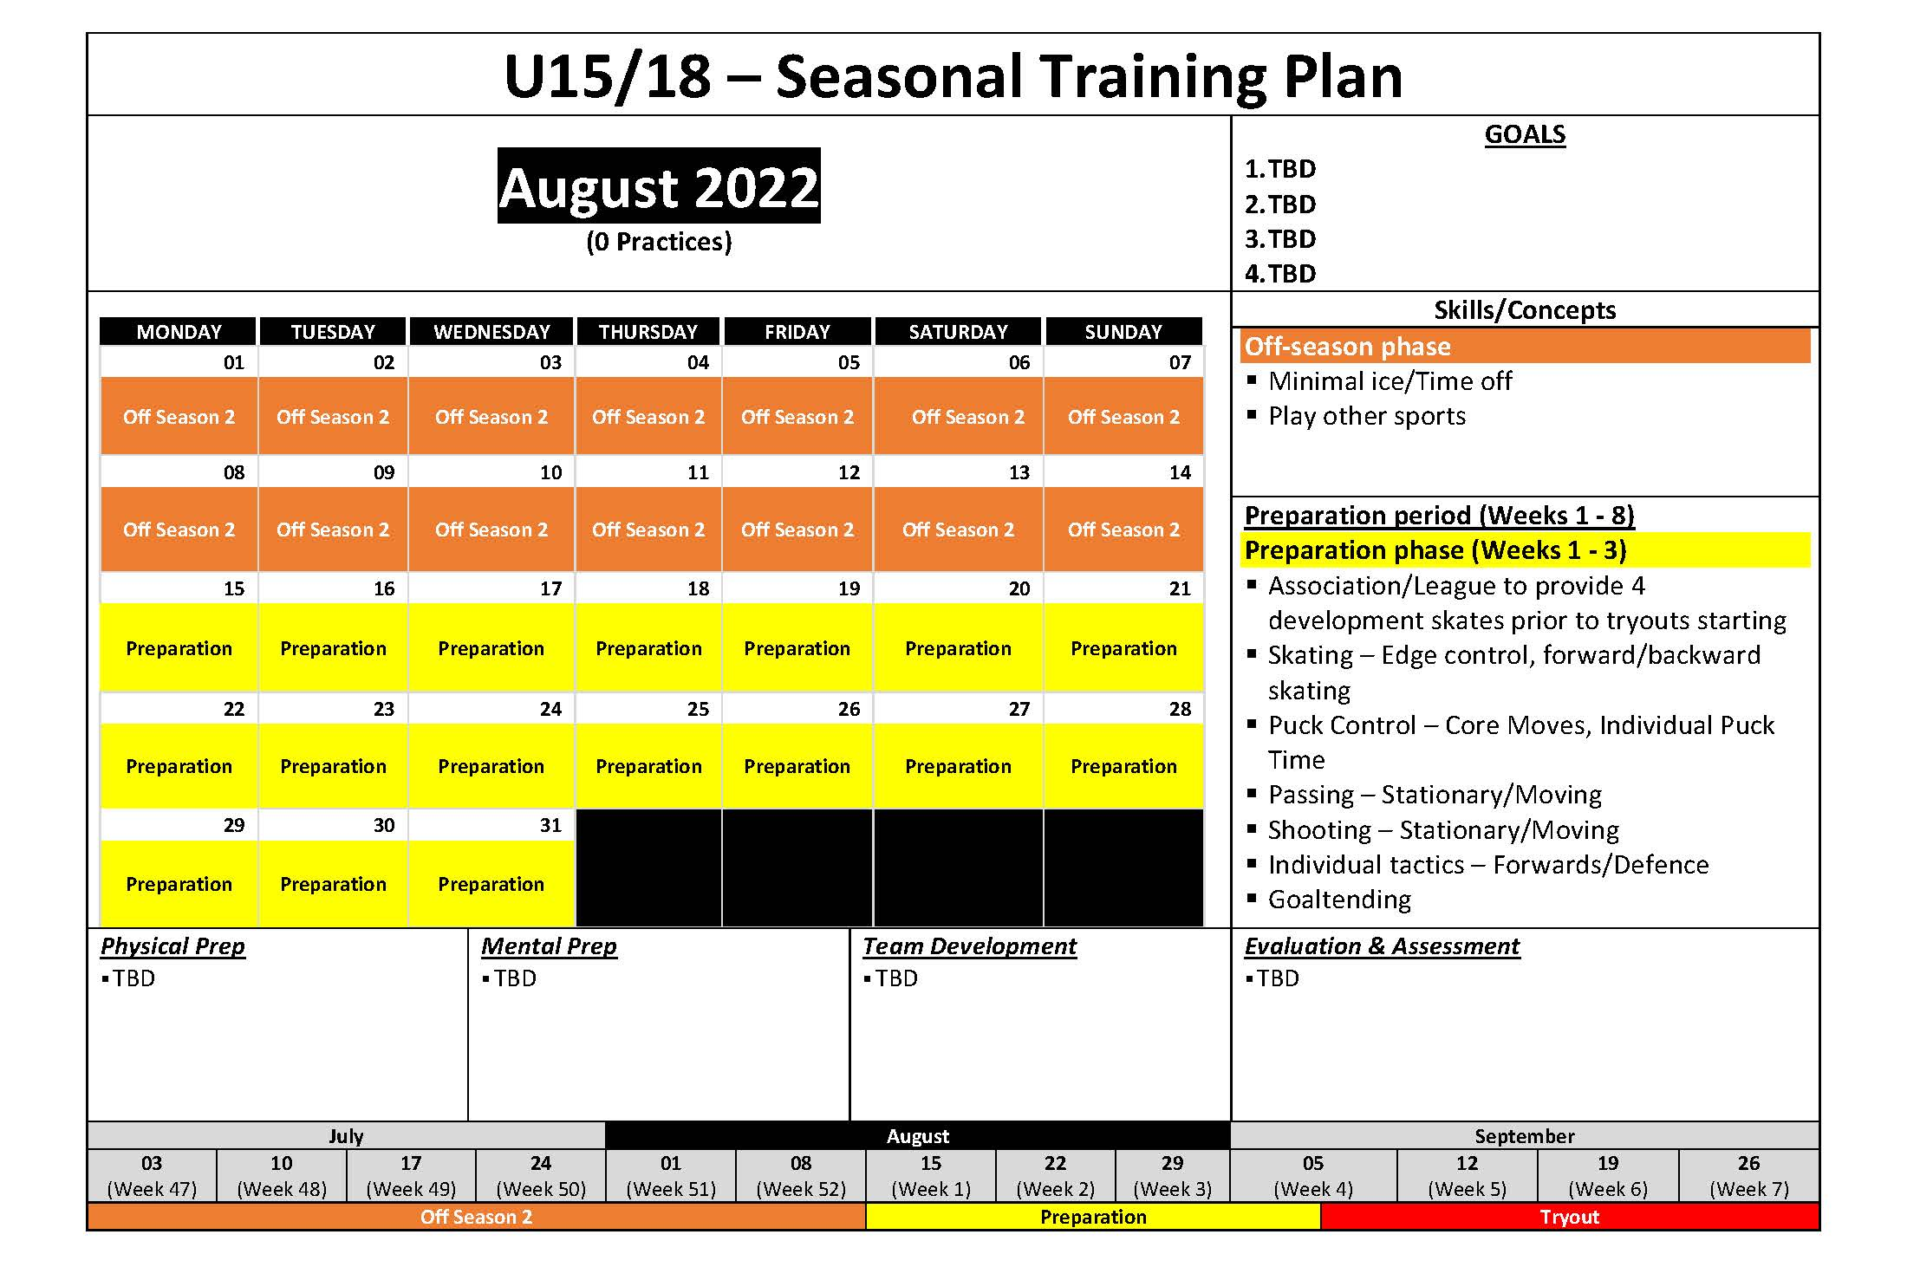

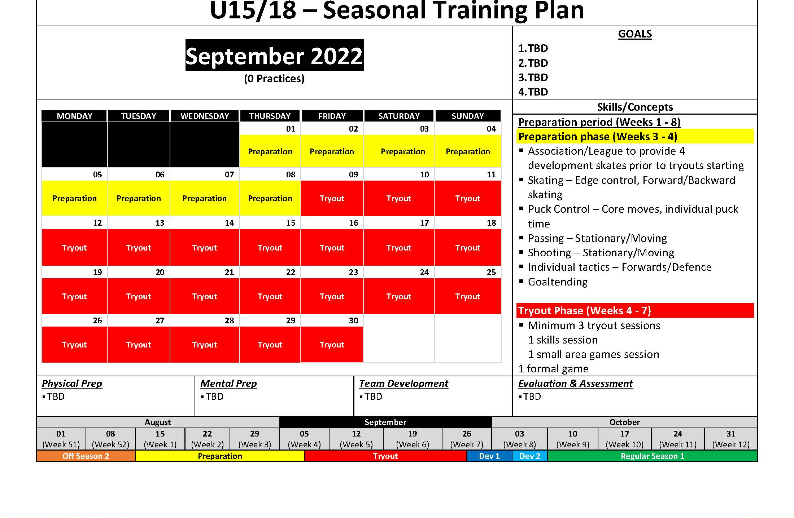

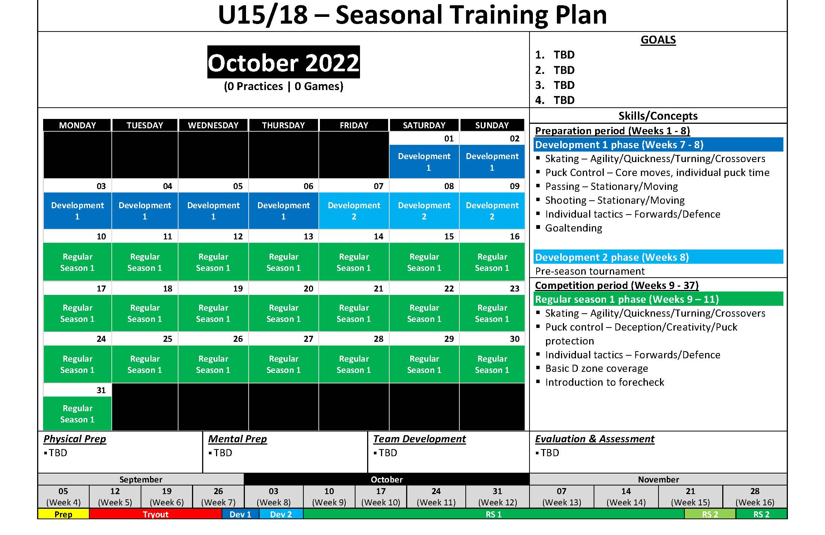

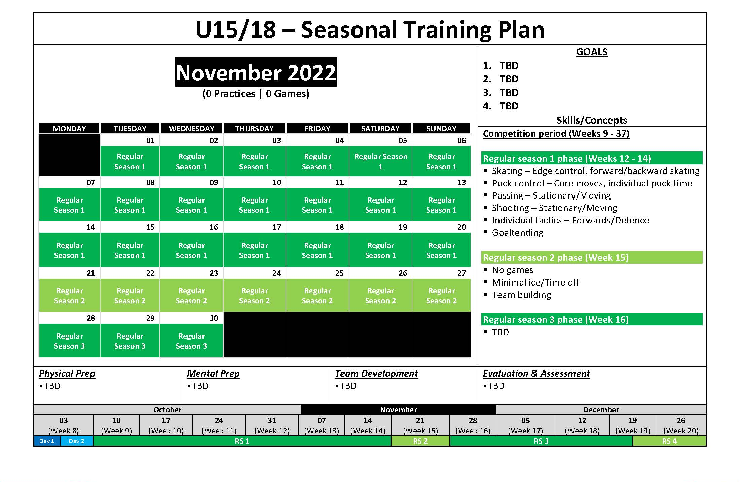

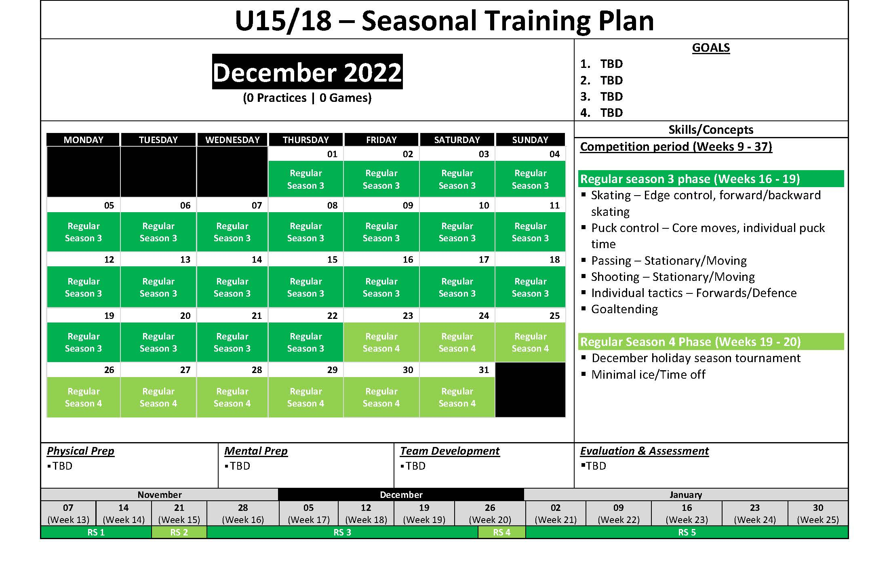

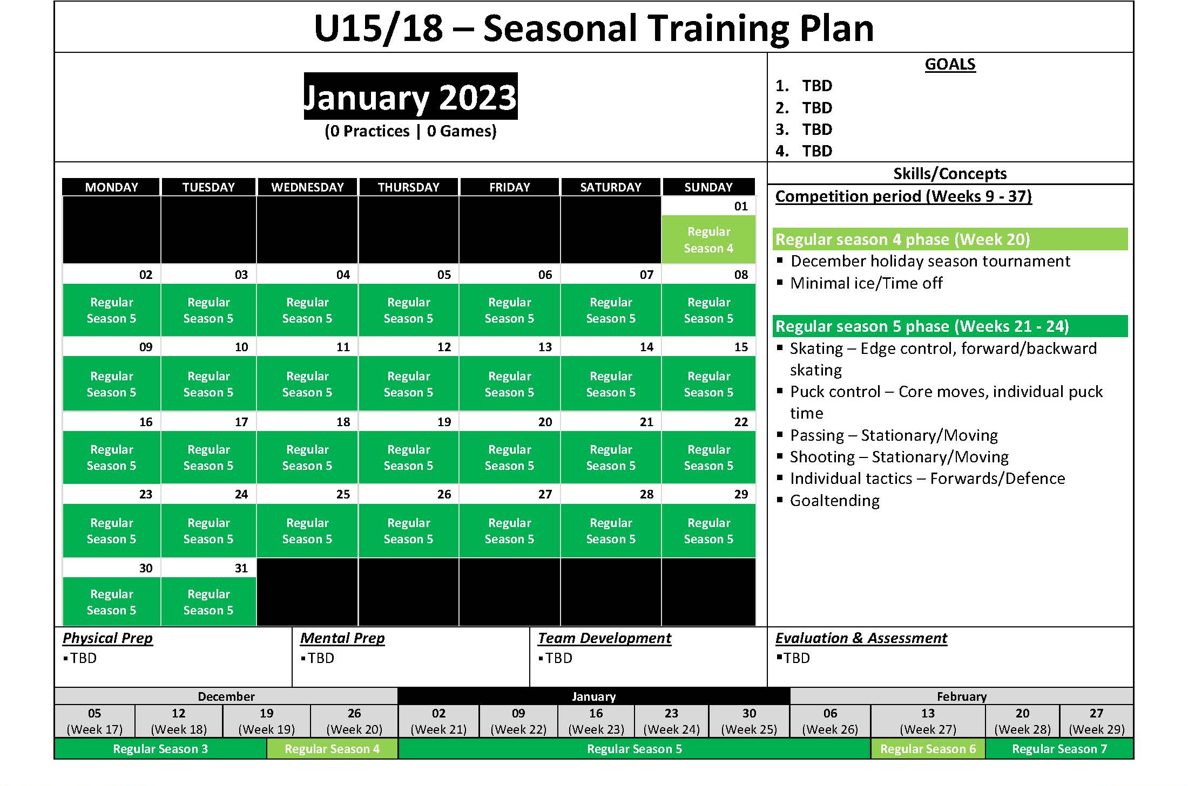

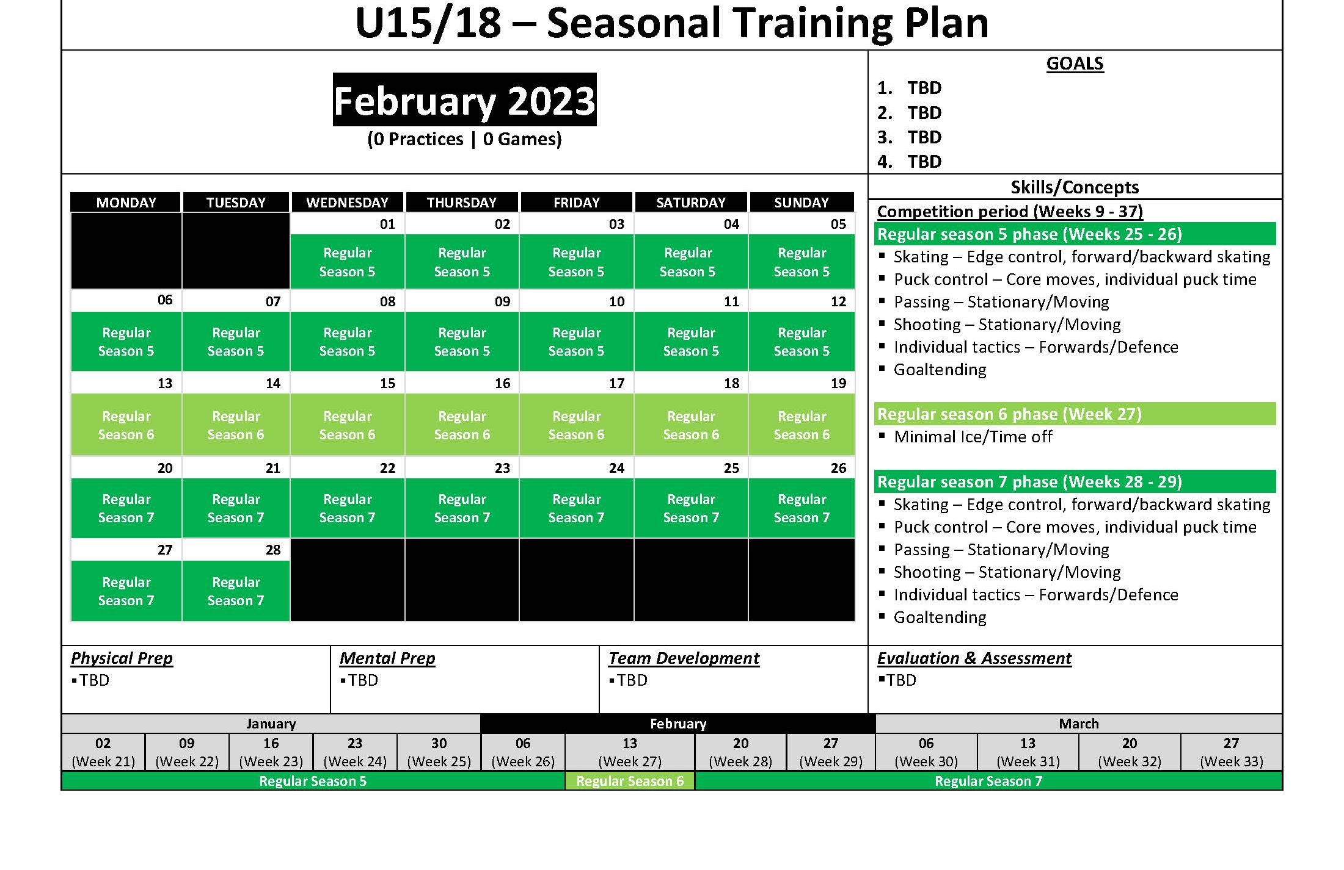

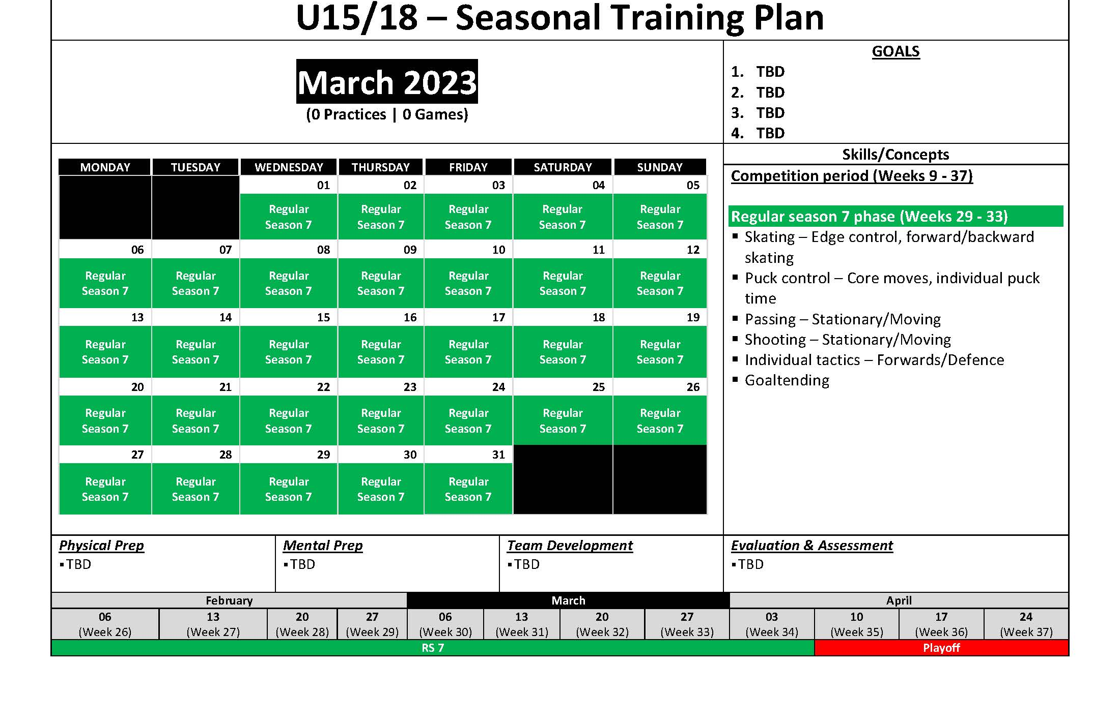

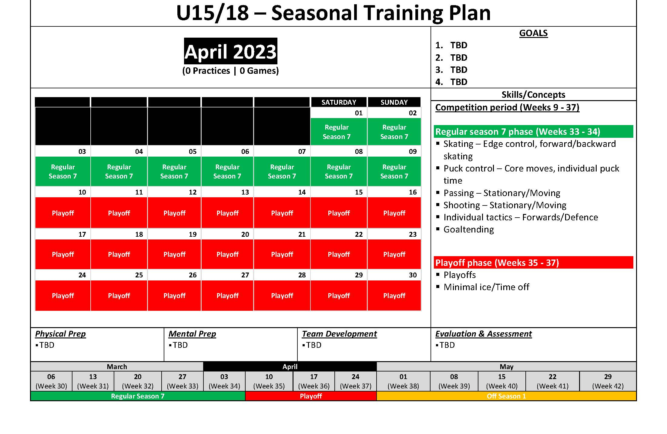

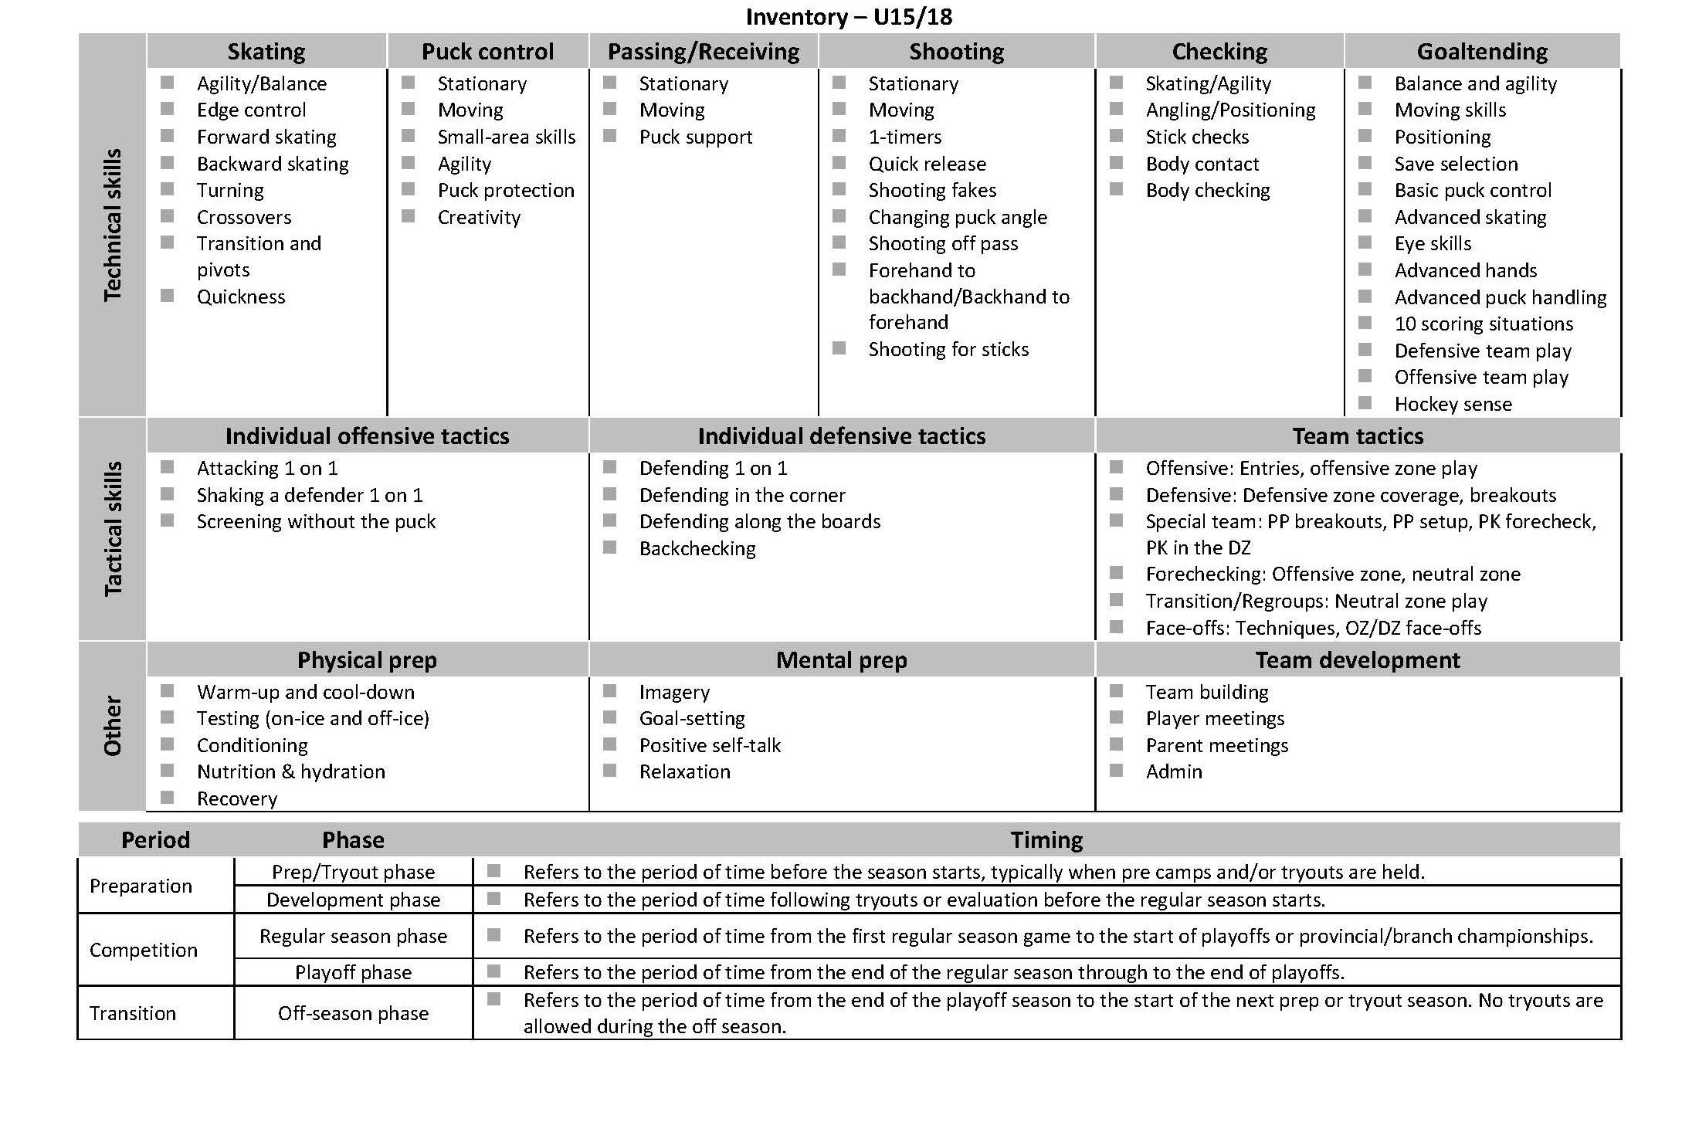

Hockey Canada coaching downloads
Check Hockey Canada’s coaching downloads for these resources on seasonal planning:
- Seasonal planning: Additional resources
- U13 seasonal plan
- U15/18 seasonal plan

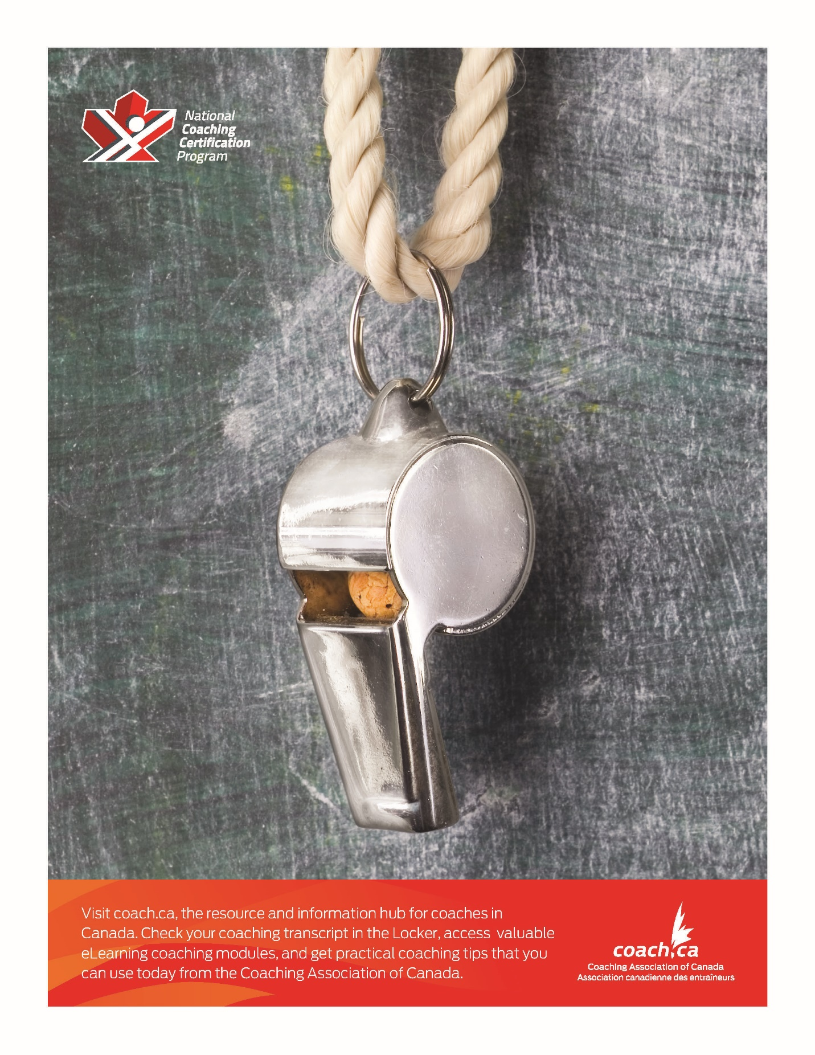

https://www.hockeycanada.ca/en-ca/hockey-programs/coaching/essentials/downloads
https://www.hockeycanada.ca/en-ca/hockey-programs/coaching/essentials/downloads
https://www.hockeycanada.ca/en-ca/hockey-programs/coaching/essentials/downloads
https://www.hockeycanada.ca/en-ca/hockey-programs/coaching/essentials/downloads
https://www.hockeycanada.ca/en-ca/hockey-programs/coaching/essentials/downloads
https://www.hockeycanada.ca/en-ca/hockey-programs/coaching/essentials/downloads
https://www.hockeycanada.ca/en-ca/hockey-programs/coaching/essentials/downloads
https://www.hockeycanada.ca/en-ca/hockey-programs/coaching/essentials/downloads

